SWOSU Center for Excellence in Teaching and Learning Newsletter August 2017

IN THIS ISSUE

Page

Marci’s Messages 1

Canvas’ best kept secret 1

Common Calls to Canvas Support 2

Engage in a Free Learning Experience 2
(Free Professional Development)

Campus Technology: Empowering the 2
World of Higher Education

UpSwing (Free Online Tutoring, 3
Anywhere, Anytime)

Nathan’s Notes 3
Zoom Training
CETL Software Training

Matching Quizzes with Images 4

New Features in Canvas
Assignment Duplication 5
Pages Duplication 6

Update Features in Canvas 6

Veronica’s Vibes 7
Technology Literacy: Zipping Files

Mapopa’s Musings 8
Principles of Instructional Design

Online Learning Consortium Workshops 9

Contacts for CETL Staff 9
Marci’s Messages
By Marci Grant
Starting off Fall 2017 Semester
Wow, can you believe it? Fall Semester is just a couple weeks away! Before we get the semester started, I wanted to make you aware of a couple of items that may help you in beginning a new Semester in Canvas. The Checklist for Beginning a Semester in Canvas that is located in Faculty Commons contains helpful information whether you are starting a course from scratch or importing the course information from another semester. When you get a chance be sure to check it out! We, in the Center, are here to help, just give us a call.
Canvas’ Best Kept Secret

Undeleting things in Canvas
This is not 100% but it is worth a try. Keep in mind if you try this and it doesn’t work. The next step would be to call Canvas Support to see if they can retrieve the items which were deleted.
Step 1 - Go the course in question.
Step 2 - Check the URL you should see something like this (your institution's name should be there)
Step 3 - At the end of the URL, type /undelete
Step 4 - Once you hit enter, you'll see a list of restorable stuff.

Common Calls to Canvas Support at the beginning of each Semester

The majority of the calls to Canvas Support at the beginning of each semester (besides not knowing what their password is) are concerning the following.

Broken Course Links
“The link to the document I am suppose to read gives me an error.”
Prior to the beginning of each semester and publishing each course, it is important to validate all the links to make sure they are still valid and the documents are contained inside the course and not another course (which students do not have access to). Just go to Course Settings and click on "Validate Links in Content" on the right side. Click here for more information.
Opening the Course Early – Changing Course Dates
“The instructor emailed me and said the course was open and I can’t find it”.
In order to have your course open prior to the term start date or close after the term end date, follow the guide "Changing Course Dates" to change the course begin and end dates.
Publish Courses – Don’t Forget!
“I can’t open my course or I can’t find my course.”
Remember, all Courses and Quizzes MUST be 'Published' in order for students to be able to access the course or take quizzes.

Engage in a Free Learning Experience (Free Professional Development)

Engage in more than a course: Engage in a Learning Experience. Enroll in open, online courses from colleges, universities, and organizations worldwide. Go to the website and find various course options: Educator Catalog, French, Girls in STEM, Portuguese, Spanish. https://www.canvas.net/

Campus Technology: Empowering the World of Higher Education

This issue of Campus Technology covers the “Teaching with Technology Survey” that Rhea Kelly asked faculty for their input on their use of technology, likes and dislikes and their view of the future. It is an interesting article that discusses how the impact of technology in teaching effectiveness, student learning, and faculty jobs. Some of the other articles in the magazine are: “Dethroning Enrollment to Put Learning First”, “Fixing the Textbook Model”, “3 ways IT is impacting Student Success”, and “When students whine about WiFi on Twitter”.

Beginning Fall 2017, all SWOSU students will have access to UpSwing’s TopUp, an online Tutoring Platform. This platform will be supplementing departmental tutoring hours provided to students. We feel one-on-one tutoring on campus is one of the great benefits our students have on campus, but we need to reach out to those students who cannot get to campus at the specific scheduled tutoring days and times.

Upswing’s TopUp is a new and exciting tutoring service where students will have 24/7 access to tutoring sessions with Upswing coaches in a variety of courses such as math, writing, science, foreign language , and more. Students can schedule times for tutoring or get immediate help if there is a coach available.

The video which explains how students can use Upswing to schedule sessions with Upswing’s coaches/tutors is accessed by the following link: How-To Video on SWOSU’s online tutoring system.

Students will have 24/7 access to Upswing’s AskUp asynchronous paper review platform with Upswing coaches. Also available to students is the UpSwing Writing Lab platform where the students will have access to videos, brainstorming tools, CiteUp citation engine and the ability to submit papers directly to the AskUp platform. In combination with Upswing real-time, 24/7 online tutoring, students can select whichever option they prefer based on the assignment, their learning style, and time until the assignment deadline. Askup is complimenting our on-campus SWOSU Writing Lab that is located in the Library.

The SWOSU’s Upswing portal is: SWOSU.upswing.io
Username: student’s email address
Password: upswing
Your Upswing password needs to be changed as soon as possible by going into settings.

Nathan’s Notes
By Nathan Thiessen
Training
Zoom is offering Daily Live Demos!! Join Zoom expert Raul Montes to learn Zoom basics: scheduling, recording, screen sharing & more.

*Mondays @ 4 pm CST (2 pm PST)
*Tuesdays @ 12 pm & 4 pm CST (10 am & 2 pm PST)
*Thursdays @ 12 pm & 4 pm CST (10 am & 2 pm PST)
*Fridays @ 12 pm CST (10 am PST)

If you will be using the following in your classes, contact Nathan Thiessen (3077 or Nathan.Thiessen@swosu.edu) for training:
Zoom Respondus LDB
Panopto Respondus Monitor
Turnitin Using ITV equipment

Matching Quizzes with images

Many teachers like to create quiz questions in which their students are asked to match images with identifying text. The multiple dropdown quiz question type will easily accommodate this type of question.
Here's how it's done:
- Although you can always add your images "on the fly," you'll probably find it easier to create the quiz question if you first upload the images you plan to use in the quiz question to your files area (either individually or as a bulk upload).
- Navigate to the Quizzes tab. You can create your new question in an existing quiz or in a question bank.
- After selecting Add Question, select the multiple dropdown type for your new question.
- Insert a table with two columns and however many rows you will need to accommodate the number of matching pairs you plan to have in your question.
- Add your pictures in the left column, resizing them as necessary; in the right column of the table, add the dropdown variables. To more closely simulate matching you can have all of the possible answers in the dropdown menus the same.
The draft view of your question will look something like this:
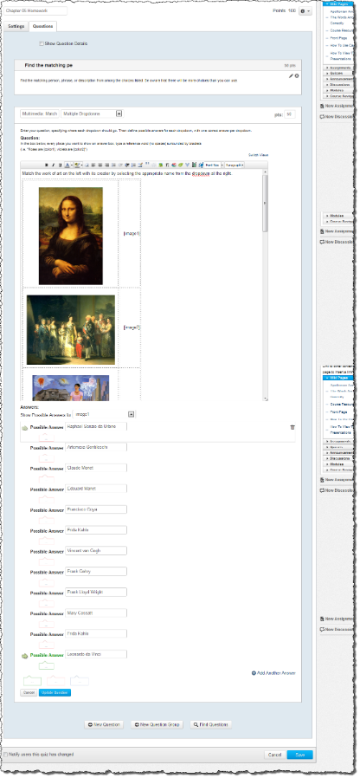

- Once you've inserted the images and the dropdown variables, you can select the correct matching choice for each image.
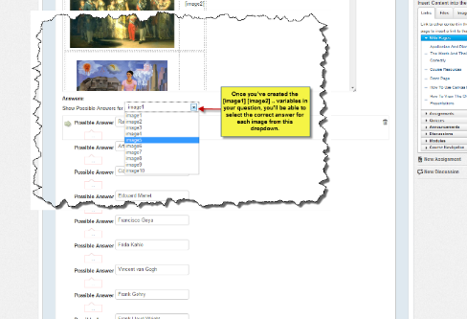

- When you've finished designating the correct matching choices for all of the pairs, click the Save button to save the question. This is how the question will look to a student taking the quiz:
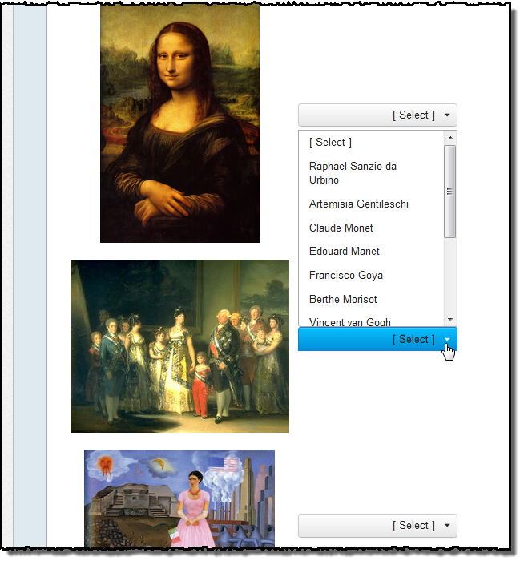
Alt tags: Before you publish the quiz, consider switching views to the HTML view to remove or change the "alt" text so students won't discover identifying information for the images by hovering their mouse cursors over them. (Need help with HTML? Read Susan Nugent's awesome blog, Rich Content Editor HTML Cheatsheet)
Extra credit: You can even create matching questions using video or audio in the left panel. For example, a music teacher might want students to identify a specific musical style by listening to a snippet from an audio file. You can insert those files or links to video in the left panel by using the Rich Content Editor to upload audio or video or by switching views to embed a video.

New Features in Canvas as of July 15, 2017

Assignment Duplication
Assignments can be duplicated in the Assignments index page. The duplication option is located in the Settings menu for every available assignment. When an assignment is copied, the word Copy is added to the end of the assignment name.

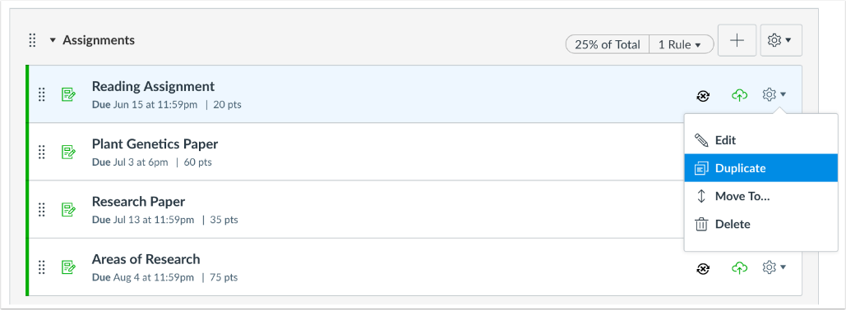

Duplicating an assignment defaults the copied assignment to an unpublished status. All items in the assignment are duplicated including the name, description, point value, and options, except for the following situations:
- Copied peer review assignments retain the peer review setting and Assign Review date, but the number of reviews per user will be set to zero.
- Copied assignments are always assigned to everyone in the course; differentiated assignments are not retained for individual users, groups, or sections.
  - If a differentiated assignment includes an Everyone Else date, the copied assignment retains the Everyone Else due date, if any. If a differentiated assignment does not include an Everyone Else date, the copied assignment does not include a due date.
- Copied external tool (LTI) assignments may need to be reconfigured.

Note: Assignments currently cannot be duplicated for discussions and quizzes. These assignment types do not include a Duplicate option in the Settings menu and will be added in a future release.

Pages Duplication
Pages can be duplicated in the Pages index page. The duplication option is located in the Settings menu for every page. When a page is copied, the word Copy is added to the end of the page name.

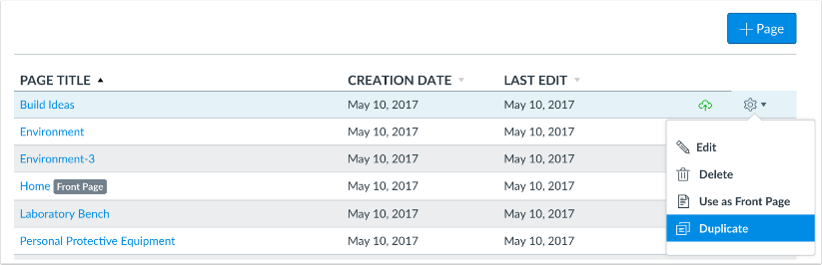

Duplicating a page defaults the copied page to an unpublished status. All items in the page are duplicated including the page name, content, and options.

Updated Features in Canvas as of July 15, 2017

Course Home Page: Modules Course Home Page Default

This feature was previously introduced as a feature option in Canvas Production Release Notes (2017-04-22) has been enabled for all Canvas accounts.

In new courses, Course Home Page defaults to the Modules layout. This change replaces the Recent Activity Stream as the Home page default. Instructors are not required to use Modules for the home page and can choose another home page layout.

Additionally, the Unpublished Course banner has been removed from the home page. Depending on an institution's preference, instructors can access either the Course Setup Checklist or the Canvas Course Setup Tutorial from the Home Page sidebar.

The Modules page includes two links to help new instructors either create a new module or add existing content through a course import.

If Modules is set to the Home page but no modules content exists, students will view the home page with no content. If modules are not used in the course, the Course Home Page should be changed to a different home page layout.

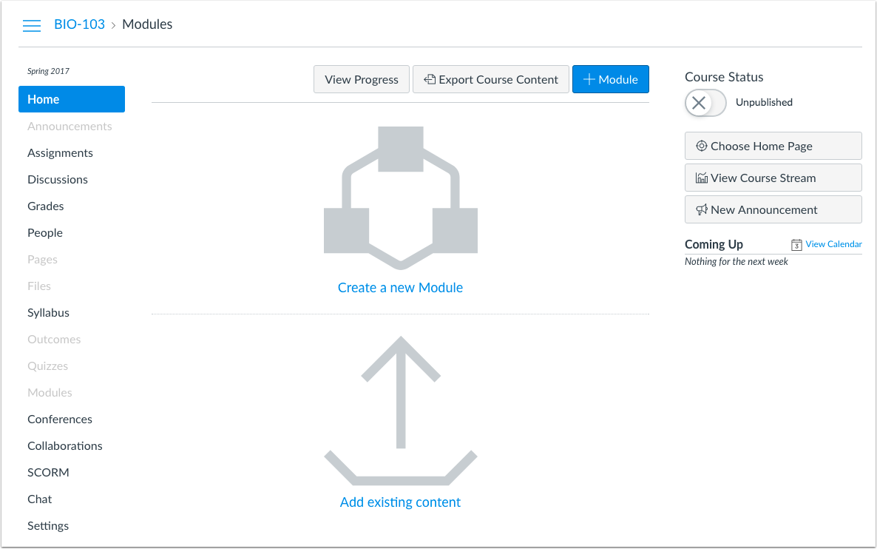

Veronica’s Vibes
By Dr. Veronica McGowan

Technology Literacy: Zipping files

Trying to send numerous files and finding that attaching each individually is a chore? Would you like to send files considerately without clogging up a friend’s inbox? In addition to these reasons, sending multiple files as a single batch fosters better organization for both the sender and receiver. So how can you zip files? This pictorial step-by-step will show you how:
First, select multiple files. Then, right click on the selection and chose Send To. Selecting the first option, Compressed (zipped) folder deploys a free zipping program included in Microsoft Windows™. You’ll immediately notice the creation of a new folder with automatic naming of one of your included files. I typically rename the folder to better describe the content. You’ll notice the folder has a different appearance that includes a zipper. At this point, the zipped folder is available for attaching in an email or other transport mechanism such as a copy procedure. When the recipient receives the folder, they have several options for obtaining the zipped content. Simply, double clicking the folder to open reveals included items which can then be treated like any file and be subject to copy, move, and deletion commands while retaining status inside the zipped folder. For more permanent storage, recipients typically extract the items (right click on folder and select Extract All) which will create a new folder of the same name on the recipient’s destination. Items will be stored as the original file size. Recipients can choose to retain the zipped folder for archive purposes or remove the zipped folder and contents.
While Window’s free compression program is convenient, third party applications such as 7-Zip™, HaoZip™, PeaZip™, IZArch™,WinRAR™, and Express Zip™, some of which a freely available, offer advanced features such as archival and split volume storage, encryption, self-extraction, and more efficient compression.
Zipping has implications for archival storage of academic documents and strategic zipping can significantly reduce storage volume for educational institutions. As an example of the volume of records management, the University of Colorado Boulder recently identified over 340 unique categories of records that need to me maintained per their retention schedule (University of Colorado, Boulder, 2017). Failure to maintain records has been shown to impact institutional funding and budget processes (Freedman & Freedman, 2006) and has been cited as a factor in the loss of accreditation status (Harris, 2012).
References
Freedman, I., & Freedman, E. (2006). Michigan audit finds that eight community colleges fumbled data reporting and record-keeping. Community College Week, 19(7), 3-3.
Harris, A. J. (2012, July 10). Mountain State University's accreditation revoked. Charleston Gazette-Mail. Retrieved from http://www.wvgazettemail.com/News/201207100059.
University of Colorado, Boulder (2017). University of Colorado Boulder Records Retention Schedule. Retrieved from https://www.cu.edu/sites/default/files/RecordRetentionUCB.pdf.

Mapopa’s Musings
By Dr. Mapopa Sanga

Principles of Instructional Design
What is Instructional Design? -Systematic Design of Instruction. Systematic process by which instructional materials are designed, developed and delivered (Dick, Carey, & Carey, 2009).
Models of Instructional Design
Three popular Models; ADDIE Initially developed by Florida State University in 1975, Assure Model developed by Heinich, Molenda, Russell, Smaldino in 1999 and the Dick and Carey Model developed by Dick, Carey and Carey in 1978. ADDIE presents a good summary of principles covered in all three.
ADDIE Model
ADDIE is a dynamic, flexible guideline for building effective instruction. In the ADDIE model, each step has an outcome that feeds into the subsequent step. The model comprises five phases: Analysis, Design, Development, Implementation and Evaluation.
Phase 1: Learner Analysis
Learners always come into a course with some knowledge, they always come knowing something. At this level of the process, entry behaviors need to be identified; who are the potential learners of the course? What do they know already and what are their learning needs? A need therefore, is the gap between what is, and what should be. As a course designer, you identify characteristics of learners and once a gap in their knowledge is identified, you identify the new behavioral outcomes (objectives).
Why do learner analysis? Because objectives and content have to be aligned with learner needs; that’s systematic.
Phase 2: Design
The Design Phase deals with lesson planning and media selection. You are planning for creation of course content. What visual and technical design strategies are you going to employ? What instructional strategies are going to be used? What assessment strategies are going to be used?
Content and assessment strategies to be developed need to be aligned with objectives; that’s systematic.
Phase 3: Development
This phase is where developer(s) (subject matter expert[s]) create and assemble the content assets that were planned in the design phase. Content is developed according to design plan and necessary technologies are integrated. In short, actual course content is developed.
Phase 4: Implementation
At this level, make sure that all resources necessary (books, hands on equipment, tools, CD-ROMs, software) are in place. Make sure learning applications and websites are functional. The course is then taught. Notable principles:
The principle of repetition: The stimulus situation and its response need to be repeated for learning to be improved and for retention to be made more certain (Gagne, 1992).
The principle of reward: Learning of a new act is strengthened when the occurrence of that act is followed by a satisfying state of affairs (that is, a reward) (Thomdike, 1913).
Phase 5: Evaluation
The evaluation phase consists of two parts: Formative and summative. Formative evaluation is present in each stage of the ADDIE process. (Examples: E.g. Small group trials, work with Instructional designer). Formative evaluation is aimed at improving the content.
Summative: Judge the worthiness of the entire program with the focus being on the outcome: Did it work as intended? Summative evaluation consists providing opportunities for feedback from the users to help facilitate redesign. (E.g. End course survey)
Revise Instruction: Use the data from the two types of evaluation to examine the validity of the instructional material and revise as needed.
References are available by contacting Mapopa at 580.774.7128

Workshops Available
The Center for Excellence in Teaching and Learning has 20 scholarships available for faculty to attend any following Online Learning Consortium workshops. If awarded, upon completion of the workshop, a certificate must be sent to CETL for their records. The cost of the workshops is $170, so, if awarded and you cannot attend, please contact CETL as soon as possible (prior to the workshop) so that a scholarship may be awarded to another faculty member.
These workshops cover a wide array of topics, examples of workshops: Designing a Flipped Classroom, Strategies to Improve Retention, Strategies to Increase Faculty Motivation, New to Online: Essentials Part 1-Getting Started, Exploring Learning Analytics, Introduction to Online Presentation Tools, Exploring Hashtags for Learning, Creating Concept Maps, etc.
If you are interested in applying for a scholarship to attend one of the following workshops, please complete the Registration form.

Center for Excellence in Teaching and Learning Staff

Marci Grant, Director
marci.grant@swosu.edu
HEC 210 3149

Dr. Veronica McGowan
veronica.mcgowan@swosu.edu
HEC208A 3147

Dr. Mapopa Sanga
mapopa.sanga@swosu.edu
HEC 209 7128

Nathan Thiessen
nathan.thiessen@swosu.edu
HEC 210 3077

