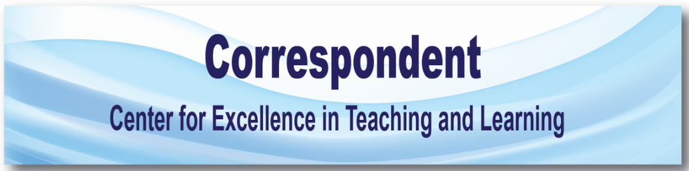
SWOSU Center for Excellence in Teaching and Learning Newsletter June 2017
IN THIS ISSUE

Marci’s messages

Canvas updates

Nathan’s Notes

Mapopa’s Musings

Veronica’s Vibes

recorded webcast: Plagerism

Marci’s Messages
By Marci Grant
WORKSHOPS OFFERED

Tuesday, August 15, 2017
HEC 216 8:30 am to noon.
We will be offering a complete Introduction to Canvas workshop for all faculty and/or staff.
Coffee and donuts will be available. Call CETL at 580-774-3149 to reserve a seat. Deadline to reserve a seat is 5:00 p.m., Friday, August 11, 2017.

Tuesday, August 15, 2017
HEC 216 1:00 to 5:00 p.m.
University Software Training and Essentials
We will discuss the various Faculty Resources in Canvas, such as Faculty Commons – Canvas resources, Certification to Teach Distance Education Courses, CETL Course Development Shell (Template) CETL Green Course (example online course), Distance Education Rubric Training, Faculty Development Faculty Training/Workshops, Resources for SWOSU, Resources for Three Pillars Course Transformation. Other software will be discussed: Zoom, Panopto, Respondus LDB, Respondus Monitor, Respondus 4.0 (exam creating), Turnitin, Upswing, Lynda.com, miscellaneous information. Call CETL at 580-774-3149 to reserve a seat. Deadline to reserve a seat is 5:00 p.m., Friday, August 11, 2017.

New things coming to Canvas on June 3, 2017
Show course announcements on course home page
Canvas has updated the announcements and home page so that recent course announcements can be shown at the top of the course’s home page.
- go into the course settings,
- click on the course details tab,
- scroll to bottom of page
- click on “more options”
- click “show recent announcements on Course home page”
- choose the number of announcements shown on the homepage
Students will now see most recent course announcements on the course homepage.
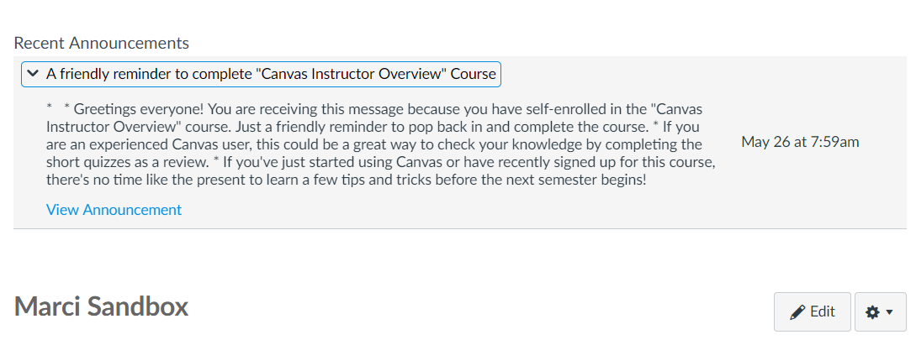
Dashboard Images on Course Cards
Individualize your course’s context card on the dashboard by adding an image. Students will see the image that faculty put on the course card. An idea would be to add an image that represents the course content, or maybe an image of the textbook’s cover.
- Go into the course settings
- Click on Feature Options tab
  - Enable Dashboard Images for Courses
- Click on the course details tab
- Click on add image
- Browse to find an image
Only instructors have the ability to add pictures to cards. Students do not have this ability.
(Canvas, cont. on page 3)

Content Export Expiration
Content exports expire after 30 days and can no longer be downloaded. Content can be exported in the content exports page in Course Settings, and the download assignment submissions page in User Settings.
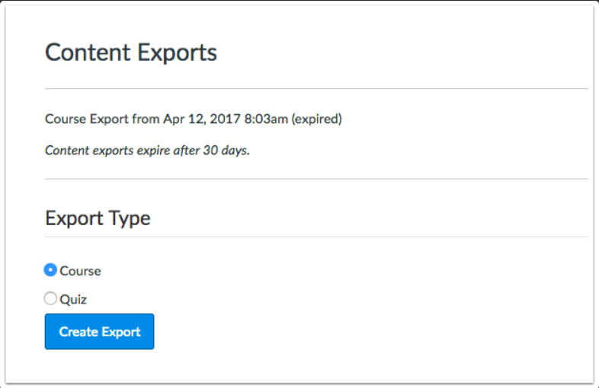
Remote Version of Rich Content Editor and Sidebar Global Availability
The Rich Content Editor sidebar enhancements that exist in Pages and the Syllabus are available in all feature areas of Canvas, including Quizzes. The sidebar enhancements include a visual style update and pagination support. Currently the sidebar enhancements only display in Pages and the Syllabus.
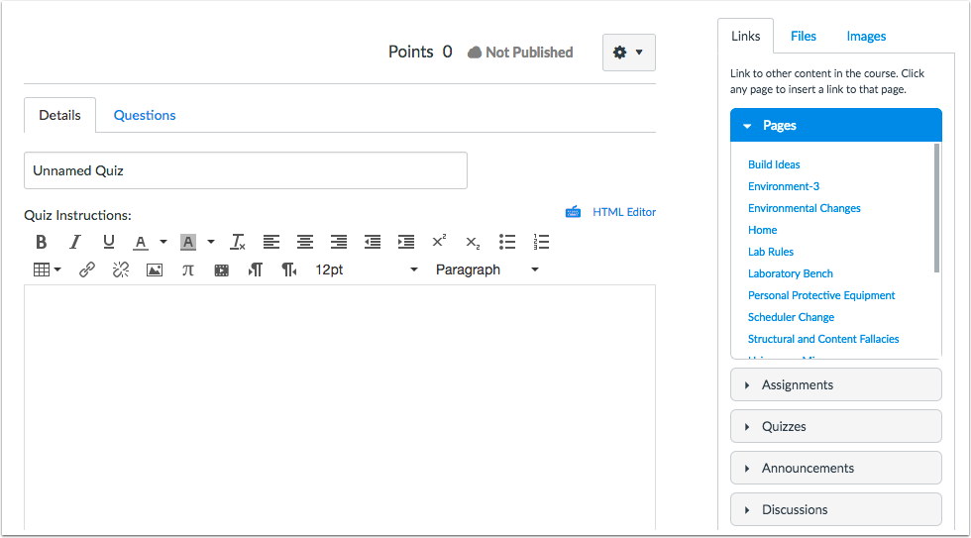
Table Context Menu
When a table is added and selected in the Rich Content Editor, the table displays a context menu. This change allows for quicker table navigation and design access.
(Canvas, cont. on page 4)

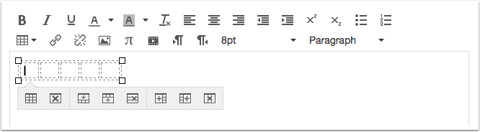
Individual View Weighted Grading Periods Display
After a student is selected from the student drop-down menu, the Student Information section in the Gradebook Individual View displays assignment groups when an individual grading period is being viewed. However, when grading periods are weighted and the All Grading Periods option is selected, the Grades section displays the weight of each grading period. Like in the grading period set, the total percentage is not displayed.
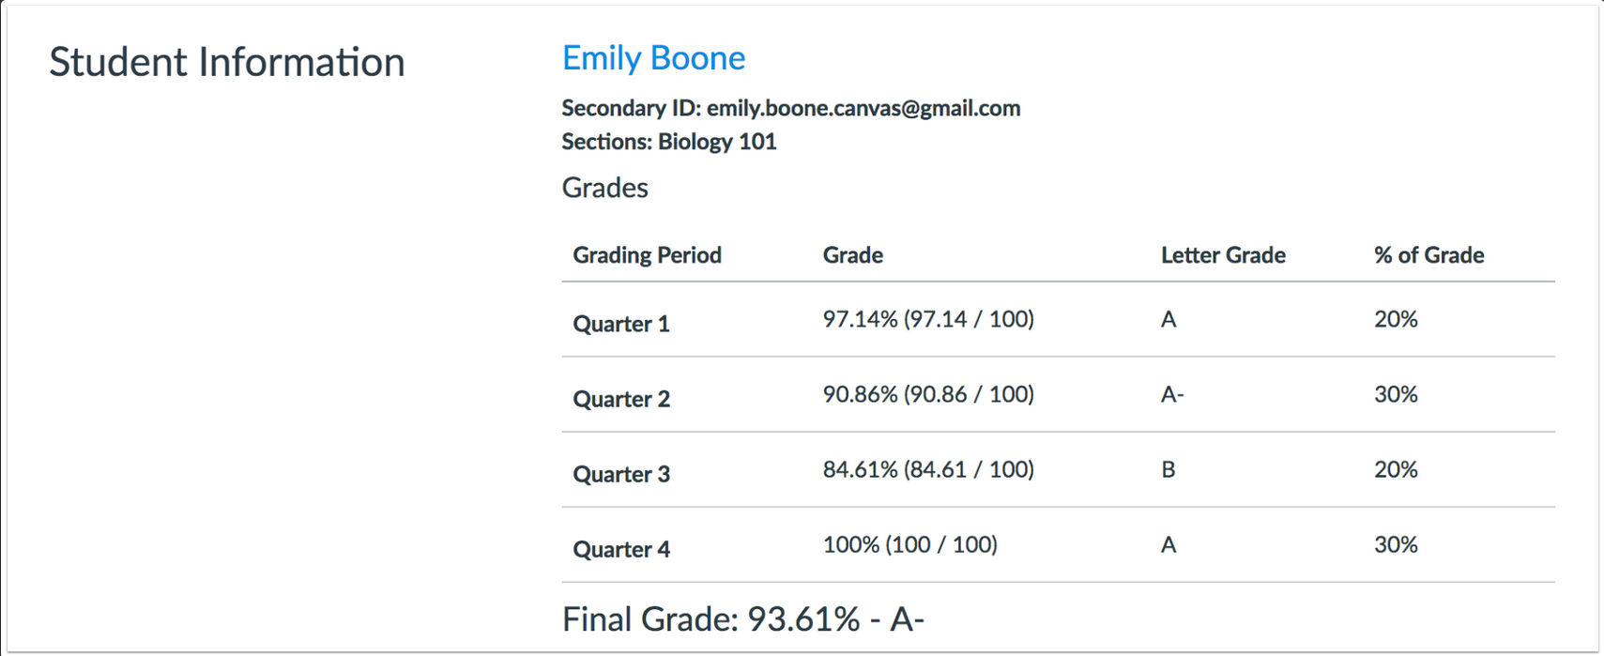

Nathan’s Notes
By Nathan Thiessen
Summer Projects

With spring semester wrapped up, CETL started its summer projects. One of them - delivering Edu-carts to many different schools across the state! Throughout the month of May, we traveled to Hooker, OK in the panhandle of the state to as far east as Drumright, OK. All of the carts are part of the grant that CETL received that will allow for more students to be reached by SWOSU. We have also updated many of the classrooms at the Sayre campus with brand new equipment. With the rise of Zoom and the many capabilities it provides, there are several rooms being revamped throughout the Weatherford campus to be Zoom compatible. Once these rooms are up and running, let us give you a tour and see if the technology would be a good fit for you.

Mapopa’s Musings
By Dr. Mapopa Sanga
A look at Online Discussion types
Working as an instructional designer over the years, I have come to conclude that writing effective discussion questions is perhaps the most important factor in developing a robust online environment. A course that develops a sense of community, based on respect and engagement, will lead to students who are more likely to participate (Lave & Wenger, 2003). A discussion forum specifically designed to increase community would be one asking students to share something they already know about the subject at hand. Students involved in collaborative interactions and learning “are likely to provide more detailed help and guidance to their peers, demonstrate more complex thinking and problem-solving skills, and obtain higher learning” (Gillies, 2015, p. 343).
Types of Discussion Questions
Textbook-based question: This is the most convenient type of forum. A question would be derived from assigned readings in the textbook, as everyone will have the book and presumably have read the assigned chapters.
Literature-based question: It involves students being instructed to find existing, discipline-specific literature to prove or disprove, agree or disagree, or expand upon the concept under discussion. This method can promote lively dialogue as students are likely to find research that attacks the concept under analysis from all directions. Students can share citations, findings,

and links that can take the discussion far in terms of discipline specific research.
Non-literature based question: Designed to present a concept or theory without relying on texts or readings. Example: Students can be directed to podcasts, audio files, streaming videos, graphics, simulations, interactive scavenger hunts, web quests, reusable learning objects, and scenarios created by the teacher and share their thoughts in a discussion. This multimedia approach will free the discussion from the literature.
Questions with an experiential element: This type Involves providing discussion forums based on the experiences of the students enrolled in the class. These are questions designed around a concept or theory being taught but aimed directly at the personal story of the student. As students open up to each other and share, the sense of community is heightened, participation is increased, and the instructor’s main role is simply to listen, and when possible, link the story to the theory.
Evaluation and reflection questions: These allow students to reflect on the course so far, the current lesson, or any other segment of the course. In response to this type of question, students can share their concerns, their opinions about the most important part of the sessions, what they found confusing, and so on.
Other types of questions include questions that ask for clarification, cause and effect questions, and summary and synthesis questions.
References are available by contacting Mapopa at 580.774.7128
Veronica’s Vibes
By Dr. Veronica McGowan
Technology Literacy: Web Cookies and Web Tracking
While most Web users are familiar with the functionality of a Web cookie (also known as HTTP cookie), the recent passage of Senate Joint Resolution 34, which repealed privacy protections, has forced Web tracking and personal privacy issues back into the news. While some Web cookies containing a small amount of text downloaded to your browser or hard drive are used to hold information such as preferences and are fairly innocuous, other types that collect consumer data for targeted advertising are a concern for privacy promoters. In this article, different cookie and Web tracking mechanisms are described with implications for protecting personal data.
Easy ways to tell if a web site is using cookies: 1) you are automatically logged in and can see account information, playlists, feeds, blogs, or other organizational constructs; 2) page content changes to push preferred information first such as local weather or sports scores; a similar example is when sites recommend content based on your history; and 3) if using a browser with very high security settings, you may be informed when a cookie is retrieved.
Cookie types of concern: Persistent cookies are transmitted every time the website is visited and can be retained for as long as the creator wishes, although others expire on a specific date or length of time. A site that uses a shopping cart or queue is typically using this cookie type to record information which may include browsing habits or login credentials.
Users can manually delete these cookie files or use an application to clean these from their computer. When a cookie’s domain attributes matches that domain, it is known as a first-party cookie and is typically not of concern to privacy advocates. Secure cookies store gift-card or credit-card related information and are only able to be transmitted over encrypted connections (see the browser URL for a HTTPS designation). Of particular concern are tracking cookies or third-party cookies accessed via a pop-up advertisement or banner advertisement. These type of cookies are typically recognized by their use of a different domain name.
Browsers can assist you in preventing web tracking; most allow you to block third-party vendors and cookies and\or initiate it’s tracking protection and private browsing features. Installing add-ons such as advertisement blockers and https maximizers such as HTTPS Everywhere will allow encryption of private conversations.

For more information, the World Wide Web Consortium’s Tracking Protection Working Group has a public mailing list (public-tracking@w3.org), the Federal Trade Commission provides information and free sources (https://www.ftc.gov/tips-advice/business-center/privacy-and-security) and the Privacy Right Clearinghouse (https://www.privacyrights.org/) provides public access to educational resources.

Recorded Webcast:
Teach Students about Plagiarism
Understanding plagiarism and its many forms is an important lesson that should be taught at every grade level. In this webinar, David Wangaard, president of The School for Ethical Education, explores the different forms of plagiarism and why many students end up unknowingly plagiarizing.

Watch the Webcast Now

