Newsletter
THE SOURCE
OFFICE OF SPONSORED PROGRAMS
Volume 3, Issue 2
February 29, 2016

SWOSU nominates senior for Research Day at the Capitol

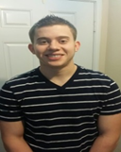
El Paso, TX senior Michael-Joseph Gorbet has been selected by Southwestern Oklahoma State University as its nominee for the 2016 Oklahoma Research Day at the Capitol. Gorbet, a chemistry and physics major, will present his research on March 29, 2016, on “New Metals (V, Pd, Ru) and New Amide Pendant-Arms for Cross-Bridged Tetraazamacrocycle Oxidation Catalysts.” Gorbet’s advisor is Dr. Tim Hubin, professor in the chemistry and physics department.
Research Day at the Capitol is held annually during each legislative session. The event was created to inform the public about the high-quality research being conducted at state colleges and universities.
Inside This Issue
Page
1 Research Day at the Capitol
1 Proposal Development Awards Announced
2 Scholarly and Academic Activity Reports
3 Grants, Contracts and Proposals
6 Funding Opportunities
8 Important Dates for 2015-2016

SWOSU Faculty chosen for Proposal SWOSU faculty selected for Proposal Development Awards

Four faculty members at Southwestern Oklahoma State University have been awarded Proposal Development Awards. The purpose of the award is to provide faculty with financial resources to draft proposals for external funding, which in turn, support research, scholarly activity, and other special projects often involving undergraduate students.
Two of the awards were funded by monies allocated annually to the SWOSU Office of Sponsored Programs, and the College of Arts and Sciences provided funding for two additional awards. Each faculty member will receive funds to assist in the development of a proposal. The awards require the recipients to prepare their proposals for submission to an external agency by early next year.
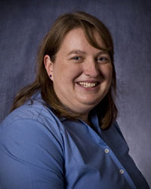
Dr. Lori Gwyn, Department of Chemistry and Physics, was awarded $5,854 to prepare a proposal on “Construction of Modular Artificial Nucleases with Macrocycle meta ligands and variable DNA binding domains.”
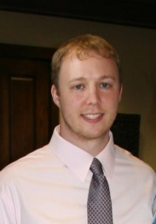
Dr. Christopher Horton, Department of Chemistry and Physics, was awarded $5,891 to work on the proposal, “Co-receptor influence on CD4+ T helper cell differentiation.”
Dr. Lori Gwyn
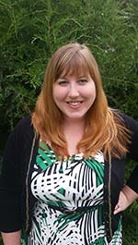
Dr. Regina McGrane, Department of Biological Sciences, was awarded $5,964 to work on the proposal, “Exploring bacterial surface sensing mechanisms and their role in pathogenicity.”
Dr. Chris Horton
Dr. Regina McGrane

continued from page 1
Dr. Doug Linder
Dr. Doug Linder, Department of Chemistry and Physics, was awarded $6,000 to prepare a proposal on “Oxidation and reduction catalysts for the production of fine chemicals.”

SCHOLARLY AND ACADEMIC ACTIVITY

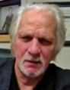
The Office of Sponsored Programs has been notified of the following Scholarly and Academic Activities since the last newsletter:

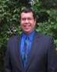
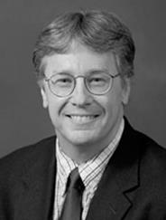
Dennis Thompson, Pharmacy Practice, has recently written and published "Systematic Review of Topical Amitriptyline for the Treatment of Neuropathic Pain," published in the Journal of Clinical Pharmacy and Therapeutics.

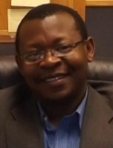
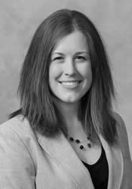
Tiffany Kessler, Pharmacy Practice, served as an article reviewer of "Comparative Cardiovascular and Cerebrovascular Safety of Inhaled Long Acting Bronchodilators in Patients with Chronic Obstructive Pulmonary Disease: a Population Based Cohort Study."

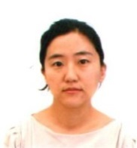
Fred Gates, Social Sciences, was a guest speaker on Sept. 3rd at the Weatherford Public Library for the Let's Talk About it Oklahoma Reading and Discussion Group. The theme was Play Ball: The American Sport meets the American Dream. Dr. Gates reviewed The Boys of Summer by Roger Kahn.

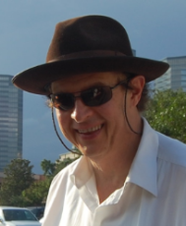
Fred Alsberg, Language and Literature, published the poems "Harry and the Shrink," "Kominsky meets Rosy," and "My Calling" in the Red Dirt Review, an online journal.

Jason Dupree, AI Harris Library, was appointed as an officer on the University of Oklahoma School of Library & Information Science Advisory Board in Norman, Oklahoma. He also participated as a discussant on the Library Leadership and Emerging Technology panel at iCon 2015 in Stillwater, Oklahoma. Also, he reviewed the article, "A Survey of Librarian Perceptions of Information Literacy Techniques" in the Communications in Information Literacy, an online journal.

Howard Kurtz, Social Sciences, served as Chair for a meeting of the South Western Association of Criminal Justice in South Padre, Texas. He also presented a paper on “British and U.S. Corrections, Paper on International Corrections” at the same meeting.

Frederic Murray, Al Harris Library, recently participated as a workshop presenter of “Digital Tools for Indigenous Curricula,” for the 2015 International Conference of Indigenous Archives, Libraries and Museums, in Washington, DC. He served as the Conference Organizer of the Challenge of Change: AIJ 5th Anniversary Conference at the Southwestern Oklahoma State University Student Center.

Guy Biyogmam, Mathematics, has recently written and published “On the Harmonic Oscillator Algebra” in the journal, Communications in Algebra.

Jieun Chang, Social Sciences, recently served as a discussant on the "Price Discrimination in Media Markets: Evidence from US Magazines" panel at the Southern Economic Association's 85th Annual Conference in New Orleans, Louisiana.
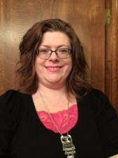
April Miller, Oscar McMahan Library, was recently appointed as a member of the Excellence in Teaching and Learning Committee. Ms. Miller also coordinated the workshop,
SCHOLARLY AND ACADEMIC ACTIVITY

continued from page 2

"Marketing Me" sponsored by OLA Marketing Committee in Moore, Oklahoma. She also gave a workshop presentation titled "Mother of Invention: Planning and Executing Marketing with Less" at the Mountain Plains Library Association Conference in Cheyenne, Wyoming.

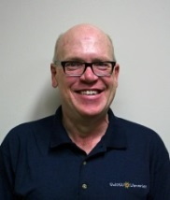
Phillip Fitzsimmons, AI Harris Library, recently published a chapter called, "The Palantiri Stones in J.R.R. Tolkien's The Lord of the Rings As Sauron's Social Media: How to Avoid Getting Poked by the Dark Lord" in the book titled, C.S. Lewis and the Inklings: Reflections on Faith, Imagination, and Modern Technology by Salwa Khoddam (Editor), Mark R. Hall (Editor), and Jason Fisher (Editor). He also wrote and published an article, "Tales of Anti-heroes in the Work of J.R.R. Tolkien," published in the journal Mythlore, No. 127 Fall/Winter 2015.

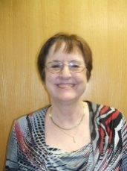
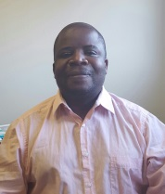
Mapopa Sanga, Center for Excellence in Teaching and Learning, recently presented a paper called “An Analysis of Technological Issues Emanating from Faculty Transition to a New Learning Management System” at the Association for Educational Communications and Technology International Conference held in Indianapolis, Indiana.

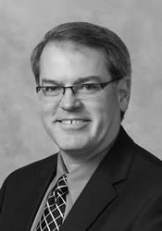
Barry Gales, Pharmacy Practice, recently served as a guest speaker and instructor at the Great Plains Family Medicine Residency Program in Oklahoma City. The subject was Drugs for Weight Loss.

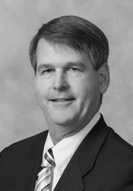
Mark Gales, Pharmacy Practice, was recently appointed as chair for the hypertension panel by the editorial board of The Annals of Pharmacotherapy.

SCHOLARLY AND ACADEMIC ACTIVITY
Faculty are encouraged to report work, such as publications, speeches, honors, conference participation or facilitation, appointments, reviews, exhibitions, poster presentations, and other such activities.
The annual scholarly and academic activity report is distributed to university and state officials and acts as an archive of such activities at SWOSU.
The Office of Sponsored Programs also forwards submissions to the SWOSU Libraries digital repository. Information pertaining to the author’s activity will not be placed in the library’s digital repository without the consent of the author. The report form is available at
http://www.swosu.edu/administration/osp/scholarly-activity-report.aspx.

GRANTS, CONTRACTS AND PROPOSALS
AWARDS
The following grants and contracts were awarded by Southwestern Oklahoma State University faculty and staff since the last report:
Madeline Baugher, Business and Computer Science. Oklahoma NASA EPSCoR Research Implementation Grant. National Aeronautics and Space Administration (NASA).
$1,885.

Madeline Baugher, Business and Computer Science. Oklahoma NASA EPSCoR Research Implementation Grant. National Aeronautics and Space Administration (NASA). $5,943.

Madeline Baugher, Business and Computer Science. Oklahoma NASA EPSCoR Research Infrastructure Development Grant. National Aeronautics and Space Administration (NASA). $1,885.

Madeline Baugher. Business and Computer Science. Oklahoma NASA EPSCoR - Research Implementation Grant (Vaidyanathan). Oklahoma NASA EPSCoR. $1,885.

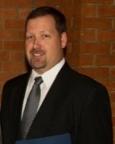
AWARDS
continued from page 3

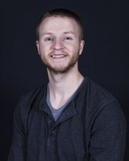
Madeline Baugher. Business and Computer Science. Space Grant College and Fellowship
Program. National Aeronautics and Space Administration (NASA). $23,539.

Madeline Baugher, Business and Computer Science. Space Grant College and Fellowship Program. National Aeronautics and Space Administration (NASA). $1,885.

Madeline Baugher. Business and Computer Science. Oklahoma Space Grant Consortium - NASA Partnership with Community Colleges. National Aeronautics and Space Administration (NASA). $22,618.
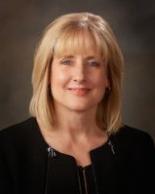
Ruth Boyd. Student Affairs. Civic Partnership Initiative Program. Campus Compact. $4,000.

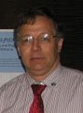
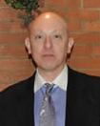
Brian Campbell and David Esjornson. Department of Chemistry and Physics. SWOSU Summer Science and Mathematics Academy. Oklahoma State Regents for Higher Education. $42,850.

Trevor Ellis. Department of Chemistry and Physics. National American Chemical Society Meeting Travel - March 2016. OK-EPSCoR. $5,000.

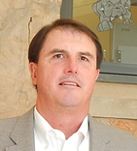
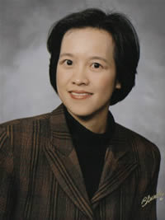
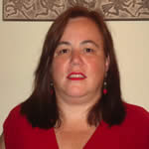
Andrea Holgado (Department of Biological Sciences), Sophie Lee (Department of Music), and Brad Bryant (Department of Engineering Technology). SWOSU Student Internship Program. Oklahoma Center for the Advancement of Science and Technology (OCAST). $30,000.

Tim Hubin. Department of Chemistry and Physics. Antifungal and anti-parasitic transition metal complexes of linked, bridged tetraazamacrocycles. National Institutes of Health. $1,335.

Nathan Smith. Pioneer Cellular Event Center. Promotion of Multiple Tourism-Focuses Events. City of Weatherford, Hotel/Motel Advisory Committee. $35,000.

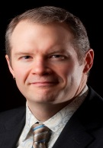
Richard Tirk. Department of Music. 46th Annual Jazz Festival. City of Weatherford - Hotel/Motel Tax Advisory Council. $2,000.

Proposals Submitted
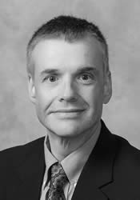
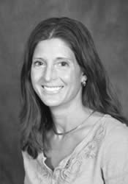
Lisa Appeddu and Les Ramos. Department of Pharmaceutical Sciences. Antioxidant and Antimicrobial Evaluation of the Potential Health Benefits of the Wild Sand Plum. OK- INBRE. $2,200.
Madeline Baugher. Business and Computer Science. Oklahoma Space Grant Consortium - NASA Partnerships with Community Colleges. Oklahoma Space Grant Consortium. $11,416.
Madeline Baugher. Business and Computer Science. Oklahoma Space Grant Consortium - NASA Partnership with Community Colleges. National Aeronautics and Space Administration (NASA). $22,618.
Madeline Baugher. Business and Computer Science. Oklahoma NASA EPSCoR Research Implementation Grant (Sellers). Oklahoma NASA EPSCoR. $1,902.
Madeline Baugher. Business and Computer Science. Oklahoma NASA EPSCoR Research Implementation Grant (Sellers). Oklahoma NASA EPSCoR. $6,092.
Madeline Baugher. Business and Computer Science. Oklahoma NASA EPSCoR - FY13 Research Implementation Grant (Teeters). Oklahoma NASA EPSCoR. $2,023.
Proposals Submitted
continued from page 4
Madeline Baugher. Business and Computer Science. Space Grant Undergraduate Student Instrument Project. Oklahoma NASA EPSCoR. $7,539.
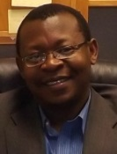
Guy Biyogmam. Department of Mathematics. The Structure of Lie-Isoclinic Leibniz Algebras. National Science Foundation. $83,075.

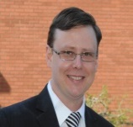
Rickey Cothran. Department of Biological Sciences. The effects of sexual selection and sexual conflict on the evolution of traits and the health of populations experiencing different ecology. National Science Foundation. (Preproposal Submission).
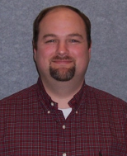
Trevor Ellis. Department of Chemistry and Physics. Synthesis of Chemical Signaling Gamma-butyrolactone (GBL) Based A-Factor Analogues. OK-INBRE. $2,200.

Trevor Ellis and Jon Henrikson. Department of Chemistry and Physics. Enhancement of Antimicrobial Production in Streptomyces Spp by Chemical Signals. OK-INBRE Collaborative Grant. $31,750.
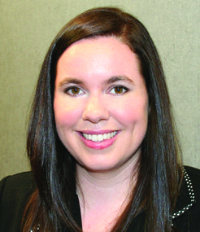
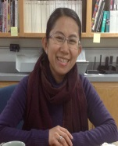
Amanda Evert. Department of Business and Computer Science. SWOSU Single Mom’s Network. Oklahoma Women’s Foundation. $5,000.
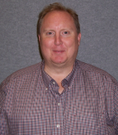
Jon Henrikson. Department of Chemistry and Physics. LC-MS Metabolomics Based Method Development of Evaluation of Changes in Antimicrobial and Secondary Metabolite Production in Streptomyces SPS. OK-INBRE. $2,200.
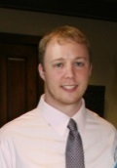
Horton, Christopher. Department of Chemistry and Physics. Co-receptor influence on T cell differentiation. OK-INBRE. $65,563.
Tim Hubin. Department of Chemistry and Physics. Inhibition of Cancer Metastasis by IL-24 Nanotherapy and CXCR4 Antagonists. National Institutes of Health. $117,720.

Tim Hubin. Department of Chemistry and Physics. Inhibition of cancer metastasis with IL-24 nanotherapy and CXCR4 antagonists. OK-INBRE Collaborative Grant. $40,766.

Tim Hubin. Department of Chemistry and Physics. Improving CXCR4 Antagonists as Anti-Cancer Imaging Agents and Therapeutics. Burroughs Wellcome Fund. $15,000.

Tim Hubin. Department of Chemistry and Physics. Improving CXCR4 Antagonists as Anti-Cancer Imaging Agents and Therapeutics. OK-INBRE Collaborative Grant. $34,133.

Andrea Holgado. Department of Biological Sciences. Analysis of autophagy in neurons. OK-INBRE. $2,200.

Andrea Holgado. Department of Biological Sciences. IOS RUI Examining molecular players integrating autophagy and axonal elongation. National Science Foundation. (Preproposal Submission).

Doug Linder. Department of Chemistry and Physics. NASA EPSCoR Travel Grant. NASA Oklahoma EPSCoR. $3,000.

Peters, Siriporn. Department of Art, Communication and Theatre. Co-Creation Digital Graphic Design and an Online System to Support the Cheyenne and Arapaho Tribes Language Program in Oklahoma. National Endowment of the Arts. $30,025.

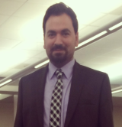
Denis Trubitsyn. Department of Biological Sciences. Transcriptional response of magnetotactic bacteria to different environments. OK-INBRE Faculty Mini Grant. $32,533.
Proposals Submitted
continued from page 5
Denis Trubitsyn. Department of Biological Sciences. RNA-level changes in magnetotactic bacteria under different culturing conditions. OK-INBRE Collaborative Grant. $69,503.

John Woods. Department of Mathematics. KESAM Statewide Partnerships 2016. Oklahoma State Regents of Higher Education. $135,000.

GRANTS, CONTRACTS AND PROPOSALS
Faculty interested in pursuing grant opportunities can contact the Office of Sponsored Programs about conducting a fund opportunity search. The process can be started by completing the Research/Scholarly Activity Interest Profile at the Office of Sponsored Programs web site at
www.swosu.edu/administration/osp/osp_interest_survey.aspx

FUNDING OPPORTUNITIES

Deadline Date(s): March 5, 2016; July 5, 2016;
November 5, 2016
Funding Agency: U.S. Department of Health
and Human Services (National Institutes of
Health)
Program Title: Education and Health: New
Frontiers (R01)
Web site: http://grants.nih.gov/grants/guide/pa- files/PAR-16-080.html
Synopsis: The goal of this funding opportunity announcement is to support research that will further elucidate the pathways involved in the relationship between education and health outcomes and in doing so to carefully identify the specific aspects and qualities of education that are responsible for this relationship and what the mediating factors are that affect the nature of the causal relationship.
Funding Range: Award is based on project

Deadline Date(s): April 26, 2016
Funding Agency: National Science Foundation
Program Title: Software Infrastructure for
Sustained Innovation
Web site: http://www.nsf.gov/publications /pub_summ.jsp?ods_key=nsf16532
Synopsis: Software is also directly responsible for increased scientific productivity and significant enhancement of researchers’ capabilities. In order to nurture, accelerate and sustain this critical mode of scientific progress, NSF has established the
Software Infrastructure for Sustained Innovation program, with the overarching goal of transforming innovations in research and education into sustained software resources that are an integral part of the cyberinfrastructure.
Funding Range: $100,000 - $1,000,000

****************************************

Deadline Date(s): May 22, 2016; August 27,
2016
Funding Agency: U.S. Department of Defense
Program Title: Awards to Stimulate and Support
Undergraduate Research Experiences-ASSURE
Web site: http://www.wpafb.af.mil/ library/factsheets/factsheet.asp?id=9333
Synopsis: The ASSURE program supports undergraduate research in DoD relevant disciplines and is designed to increase the number of high-quality undergraduate science and
engineering majors who ultimately decide to pursue advanced degrees in these fields. The
ASSURE program aims to provide valuable research opportunities for undergraduates, either
through ongoing research programs or through projects specially designed for this purpose. Research projects should allow high quality interaction of students with faculty and/or other research mentors and access to appropriate facilities and professional development opportunities.
Funding Range: $70,000 - $120,000 per year

FUNDING OPPORTUNITIES

continued from page 6

Deadline Date(s): June 17, 2016
Funding Agency: National Science Foundation
Excellence in Science, Mathematics and
Engineering Mentoring
Web site: http://www.nsf.gov/pubs/2016/ nsf16534/nsf1654.htm
Synopsis: The Presidential Awards for Excellence in Science, Mathematics and Engineering Mentoring (PAESMEM) is a Presidential award established by the White House in 1995. The PAESMEM program is administered by the National Science Foundation (NSF) on behalf of the White House Office of Science and Technology Policy (OSTP). Exceptional STEM or STEM-related mentoring in both formal and/or informal settings are eligible for the PAESMEM award. Nominations for the PAESMEM award may be submitted by any individual U.S. citizen or permanent resident or affiliated organization conducting science, technology, engineering and mathematics (STEM or STEM-related) mentoring activities.
Funding Range: 16 awards of $10,000

****************************************

Deadline Date(s): September 1, 2016
Funding Agency: The Presser Foundation
Program Title: Undergraduate Music Scholar
Award
Web site: http://www.presserfoundation.org/ ?page_id=113
Synopsis: The Presser Foundation is one of the few foundations in the United States dedicated solely to the support of music and music education. Undergraduate schools of music at accredited colleges, universities, and independent institutions of higher education are invited to apply for the opportunity to present this award to one outstanding music major they will select.
Funding Range: $4,000 at beginning of Senior
Year

Deadline Date: April 14, 2016
Funding Agency: National Endowment for the
Arts
Program Title: NEA Challenge America
Web site: https://www.arts.gov/grants-organizations/challenge-america/grant-program-description
Synopsis: The Challenge America category offers support primarily to small and mid-sized organizations for projects that extend the reach of the arts to underserved populations -- those whose opportunities to experience the arts are limited by geography, ethnicity, economics, or disability. Age alone does not qualify a group as underserved; at least one of the underserved characteristics also must be present. Grants are available for professional arts programming and for projects that emphasize the potential of the arts in community development. Challenge America grants extend the reach of the arts to underserved populations and are limited to the specific types of projects.
Funding Range: $10,000 with a $10,000 match

****************************************

Deadline Date: May 16, 2016
Funding Agency: U.S. Department of Health and
Human Services (NIH)
Program Title: High-End Instrumentation
(HEI) Grant
Web site: http://grants.nih.gov/grants/guide/pa-files/PAR-16-053.html
Synopsis: The purpose of this funding opportunity is to continue the High-End Instrumentation (HEI) Grant Program administered by ORIP. The objective of the Program is to make available to institutions expensive research instruments that can only be justified on a shared-use basis and that are needed for NIH-supported projects in basic, translational or clinical areas of biomedical/behavioral research. The HEI Program provides funds to purchase or upgrade a single item of expensive, specialized, commercially
available instrument or an integrated instrumentation system.
Funding Range: $600,000 - $2,000,000

FUNDING OPPORTUNITIES

continued from page 7

Deadline Date(s): October 1, 2016
Funding Agency: American Society of
Pharmacology and Experimental Therapeutics
(ASPET)
Program Title: Pharmacology-related Research
Web site: http://www.aspet.org/awards /SURF/institutional/
Synopsis: The purpose of the fellowships is to introduce undergraduate students to pharmacology research. The goal is to use authentic, mentored research experiences in pharmacology to heighten student interest in careers in research and related health care disciplines.
Funding Range: $2,800 for a minimum of ten weeks participation that includes ASPET support of $1800/student for at least 5 students per year of funding with matching funds of $1000 per student.

Upcoming Events
OKLAHOMA RESEARCH DAY 2016

The 17th Annual Oklahoma Research Day for regional universities will be held Friday, March 11, 2016, on the Northeastern State University campus in Tahlequah, Oklahoma.
Time: 8:30 a.m. to 3:00 p.m.

Three university vehicles have been reserved to transport faculty and students to the event. Due to the length of the trip, we will be leaving on Thursday, March 10, 2016 at 3:00 and 5:00 p.m. Transportation assignments have been distributed to faculty and students.
Two hotels have been identified near Northeastern State University’s campus for lodging. They are listed below:
Holiday Inn Express – 2143 Mahaney Avenue, 918-506-4545 ($89.00 per night/ government rate/Choice of one king or two queens)
Quality Inn –3296 S. Muskogee Avenue, 918-458-1818 ($60.00 per night/Choice of one king or $10 more for two queens)
Please feel free to contact the Office of Sponsored Programs with any questions. Also, for further information about Oklahoma Research Day, please contact Kathi Schoonover at (918) 444-2243 or schoonok@nsuok.edu.

RESEARCH DAY AT THE CAPITOL
Research Day at the Capitol will be held at the State Capitol rotunda on Tuesday, March 29, 2016 from 7:45 a.m. - 2:00 p.m. Students must be nominated by their institutions for the honor of presenting posters at Research Day at the Capitol.

23RD ANNUAL SWOSU RESEARCH AND SCHOLARLY ACTIVITY FAIR
The 23rd Annual Research and Scholarly Activity Fair is scheduled for Tuesday, April 19, 2016, at Southwestern Oklahoma State University. The fair will be from noon to 3 p.m. at SWOSU’s Memorial Student Center Ballroom.
An application is required to present at the fair and is accessible on the SWOSU web site at http://www.swosu.edu/administration/osp/fair/application.aspx. The application process is through on-line submission only.
The application deadline is Monday, March 7, 2016. A participant must present in poster, podium, or fine arts format.
More information or application assistance is available by contacting Dr. Lisa Appeddu, Chair, University Research and Scholarly Activity Committee (“URSAC”) via e-mail lisa.appeddu@swosu.edu or (580) 774-3148 or the Office of Sponsored Programs via email at osp.edu (580) 774-7012.

Upcoming Events
continued from page 8
CUR BIENNIAL CONFERENCE 2016
CUR is hosting its 17th National Conference, “Advancing Undergraduate Research: Collaboration and Innovation in a Global Society”, at the University of South Florida, Tampa, one of only four Florida public universities classified by the Carnegie Foundation for the Advancement of Teaching in the top tier of research universities. The conference date is June 26-28, 2016.
The 2016 CUR National Conference provides an opportunity for faculty, administrators, staff, academic and community partners, and policy-makers to share individual and collaborative investigations, either interdisciplinary or cross-disciplinary, in local, national and international contexts, and to showcase models of undergraduate research activities at all types of higher education institutions. In addition, the conference features nationally-recognized keynote speakers who provide insight into current national/global trends and related fields of interest.
The last day to register at the early-bird rate is April 25, 2016. Registration closes on May 25, 2016. For more information, please visit the website at
http://www.cur.org/conferences_and_events/biennial2016/

OFFICE OF SPONSORED PROGRAMS STAFF
Dr. Yolanda Carr, Director
yolanda.carr@swosu.edu
***
Ms. Kem Mendizabal, Grants Specialist
kem.mendizabal@swosu.edu
***
ADM 201
(580) 774-7012
osp@swosu.edu

