Newsletter
THE SOURCE
OFFICE OF SPONSORED PROGRAMS
Volume 3, Issue 3
April 30, 2016

SWOSU Awarded Grant for Single Moms’ Network
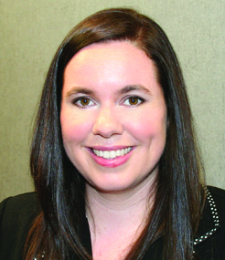
The Women’s Foundation of Oklahoma, in their effort to create economic self-sufficiency for Oklahoma women and girls, has awarded a grant to Southwestern Oklahoma State University in the amount of $3,500 to establish the SWOSU Single Moms’ Network. The purpose of this program at SWOSU is to provide a network of support services designed to empower single moms’ to complete degrees. Dr. Patsy Parker, Associate Dean for the School of Business and Technology states, “earning a college degree leads to increased earning power and success for anyone. Empowering single moms to complete a college, however, affects entire families. The Single Mom’s Network grant is an important initiative that will serve the SWOSU community well.”
This initiative was begun last year when the Women’s Foundation of Oklahoma awarded their first seven grants to Oklahoma colleges and universities. “Research states that in the 2011-2012 academic year, U. S. colleges and universities enrolled 3.5 million students who are also single parents, a group that represents 15.2% of the undergraduate population. Oklahoma currently has over 32,000 who are single parents with the majority headed by single mothers, and of these only 10% earn their degrees in a timely fashion.
Dr. Ken Rose, Dean of Professional and Graduate Studies states, “having grown up in a
Inside This Issue
Page 1 Singles Moms’ Network Grant 8 Grants, Contracts, and Proposals
2 Research Day at the Capitol 9 Proposals Submitted
2-3 Scholarly and Academic Activity 10 Funding Opportunities
4-7 Oklahoma Research Day 11-12 Upcoming Events

single parent home, I know it is especially hard on everyone involved. Had my mother not had a college degree, my mother, sister, and I would have been in a terrible situation.”
Dr. Amanda Evert, director of the
program, will identify four exceptional SWOSU individuals to serve as program coordinators and club advisors. These individuals will have both a passion for supporting single moms and a desire to lay the foundation for the program that will extend beyond 2016-2017 grant funding. “This is the third grant I have co-authored for SWOSU,” states Dr. Evert. “It is great to be part of a team that encourages and supports innovation. It is clear that SWOSU is a student-focused institution with a mission to bring exceptional opportunities to western Oklahoma.”
The funds from the Oklahoma Women’s Foundation will be used for speakers, professional development activities, fellowship events, and emergency support. Luncheons will also be scheduled with SWOSU single mom mentors. After the successful first year, the program club advisors plans to submit the official paperwork to make the SWOSU Single Moms’ Network a recognized university club. The club will then have the option of applying for student activity funds to support mentor luncheons, resource fair, focus groups, and networking events.

Research Day at the Capitol

Research Day at the Capitol was held at the State Capitol rotunda on Tuesday, March 29, 2016 from 7:45 a.m. - 2:00 p.m. Students must be nominated by their institutions for the honor of presenting posters at Research Day at the Capitol.
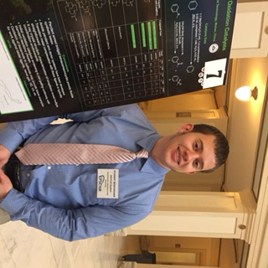Michael –Joseph Gorbet
Gorbet, a senior chemistry major, was one of 24 undergraduate student researchers from 18 Oklahoma colleges and universities who displayed their projects Tuesday during Research Day at the Capitol. Michael-Joseph is developing catalysts that one day could prevent heavy metal contamination in industrial environments and decontaminant chemical welfare agents.
His research is built on the research of his professor, Dr. Tim Hubin, and others before him. Students shared their research findings, which addressed important topics including water quality and renewable energy, malaria research, cardiac regeneration therapy, and breast cancer. Posters are competitively judged by an independent panel that selected the top seven research presentations in three categories.
Research Day at the Capitol is sponsored by the Oklahoma Experimental Program to Stimulate Competitive Research (EPSCoR) through a National Science Foundation grant and the Oklahoma State Regents for Higher Education.
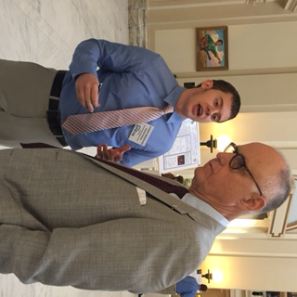Michael-Joseph Gorbet sharing his research project with State Representative Harold Wright.

Scholarly and Academic Activity

The Office of Sponsored Programs has been
notified of the following Scholarly and Academic Activities since the last newsletter:

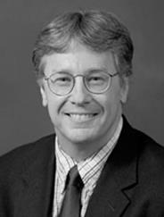
Dennis Thompson, Pharmacy Practice, has recently been appointed to the Continuing Education Committee for the Oklahoma State Board of Pharmacy. He also was appointed to the Board of Trustees of the Weatherford Regional Hospital. Dr. Thompson published “Role of Clonidine in Neonatal Abstinence Syndrome: A Systematic Review” in the journal Annals of Pharmacotherapy. He also reviewed the articles, “The Orphan Drug Act and Pediatric Mitochondrial Disease Drug Development” and “The Story Behind Drug Trade Names: A Deeper Insight into the Egyptian Drug Market” at the American College of Clinical Pharmacy Annual Meeting Abstracts. Dr. Thompson was re-appointed as chair of the drug information panel by the editorial board of the Annals of Pharmacotherapy.

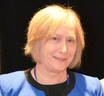
Dorie Astle, Criminal Justice and Sociology, recently wrote and published the article, “The Death Penalty: Baze, Gossip and Beyond,”
in the Oklahoma Bar Journal published by the Oklahoma Bar Association.

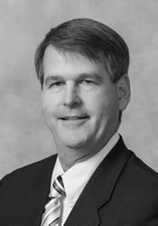
Scholarly and Academic Activity

continued from page 2

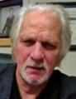
Howard Kurtz, Social Sciences, served as the University outside reviewer for the American Council on Education in Washington, D. C. Dr. Kurtz also recently presented a paper, Sociological Presentation on Gender Roles and College, and served as a consultant on the Crime Presentation “Parricide” at the Southwestern Sociological Association in Las Vegas, Nevada. Other recent activities include serving as a consultant for the State Conference for Oklahoma at the Academy of Criminal Justice Sciences National Meeting in Denver, Colorado, and, making a presentation on Crime at a meeting of the Oklahoma Criminal Justice Association in Edmond, Oklahoma.

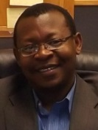
Guy Biyogmam, Mathematics, has recently reviewed the article, “Some Extremal Properties of the Variety of Leibniz Algebras Left Nilpotent of Class at Most Three,” for the American
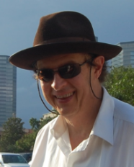
Mathematical Society. Dr. Biyogmam wrote and published, “A Relative Theory for Leibniz n-Algebras,” in the Algebra Colloquium.

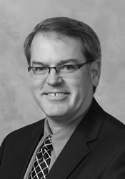
Barry Gales, Pharmacy Practice,
recently reviewed the article, “Asthma
as a comorbidity in hospitalized
patients: A potential missed opportunity to intervene” in the Annals of Pharmacotherapy. Dr. Gales spoke on “Clinical Pharmacogenomics” at the Great Plains Family Medicine Residency Program in Oklahoma City, Oklahoma.

Philip Fitzsimmons, Al Harris Library, recently presented his paper, Owen Barfield and “Is Man a Myth?” at the 19th Annual C.S. Lewis and Inklings Society Conference in Siloam Springs, Arkansas.

Mark Gales, Pharmacy Practice, recently reviewed the article, “Continuous Infusion Labetalol vs. Nicardipine for Hypertension Management in Stroke Patients,” in the Annals of Pharmacotherapy. Dr. Gales has been appointed to the Integris CME Planning and Review Committee at Integris Baptist Medical Center in Oklahoma City, Oklahoma.

Brooke Gildon, Pharmacy Practice,
was appointed as chair of the Pediatric Pharmacy Advocacy Group Ambulatory Care Special Interest Group for the national organization SIG. She also served as an article reviewer of “Pediatric Asthma Update” in the RX Consultant, and “The Role of Clonidine in Neonatal Abstinence Syndrome: A Systematic Review” for the Annals of Pharmacotherapy. Dr. Gildon has recently written and published “Appropriateness of Oral Medication Delivery Devices available in Community Pharmacies” in The Journal of The American Pharmacists Association.

Fred Alsberg, Language and Literature, recently performed a reading of original Poetry at the PCA-ACA National Conference in Seattle, Washington.

SCHOLARLY AND ACADEMIC ACTIVITY
Faculty are encouraged to report work, such as publications, speeches, honors, conference participation or facilitation, appointments, reviews, exhibitions, poster presentations, and other such activities.
The annual scholarly and academic activity report is distributed to university and state officials and acts as an archive of such activities at SWOSU.
The Office of Sponsored Programs also forwards submissions to the SWOSU Libraries digital repository. Information pertaining to the author’s activity will not be placed in the library’s digital repository without the consent of the author. The report form is available at
http://www.swosu.edu/administration/osp/scholarly-activity-report.aspx.

Oklahoma Research Day 2016 Tahlequah, OK
Approximately 54 SWOSU faculty and students attended the Oklahoma Research Day in Tahlequah, OK on March 11, 2016. There were 40 schools, 15 states, and 4 countries represented at the 2016 Fair. Northwestern Oklahoma State University will host ORD for the next two years at the Enid Convention Center.
The following faculty and students from Southwestern Oklahoma State University presented research projects at the 2016 Oklahoma Research Day:
COLLEGE OF ARTS AND SCIENCES

Art, Communication, and Theatre
Participatory Graphic Design for Safeguarding Cultural Heritage
Siriporn Peters, Faculty

Life in Oklahoma as an Exchange Student
E.K. Jeong, Faculty
Jeongmin Lee, Student
Heeeun Kim, Student

Biological Sciences
Use of Species Specific Interferons in Veterinary Medicine
Denis Trubitsyn, Faculty
Jaci Peetoom, Student
Sublethal Effects of Malathion on Amphipod
Life History Traits
Rickey Cothran, Faculty
Lindsey Hendricks, Student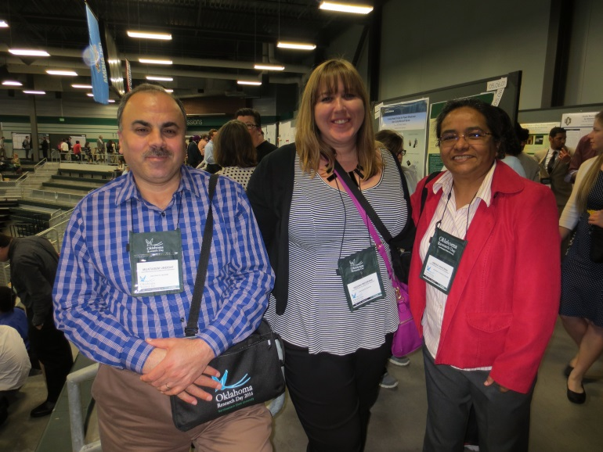
Faculty members Drs. Muatasem Ubeidat, Regina McGrane, and Jimena Aracena at ORD.
Patch Location Preference During Foraging in Fruit Flies (Drosophilia Melanogaster)
Jimena Aracena, Faculty
Courtney Gunning, Student

Pupation Height Differences in Field Collected and Laboratory Fruit Flies (Drosophilia Melanogaster)
Jimena Aracena, Faculty
Jessica Huffman, Student

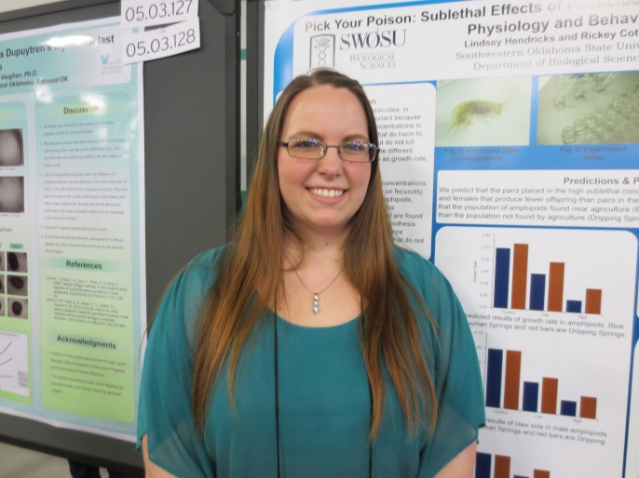
Student Lindsey Hendricks

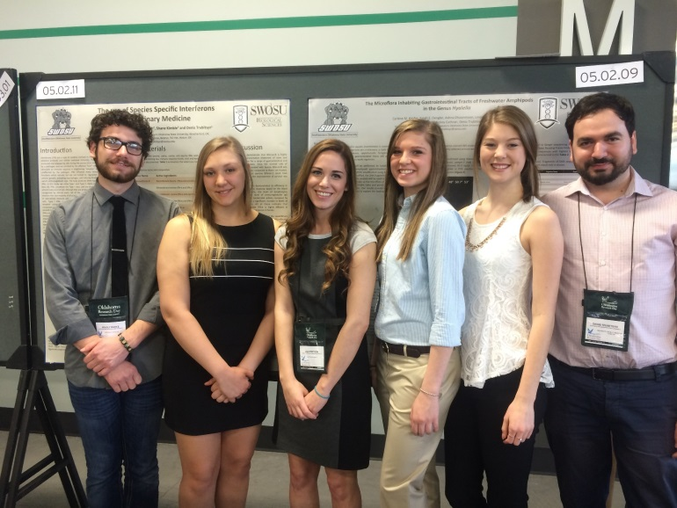
Students Bradly Burke, Mazie Earl, Jaci Peetoom, Sarah Dengler, Carlene Kinder, and Dr. Denis Trubitsyn at ORD.

The Microflora Inhabiting Gastrointestinal Tracts of Freshwater Amphipods in the Genus Hyalella
Denis Trubitsyn, Faculty
Rickey Cothran, Faculty
Carlene Kinder, Student
Sarah Dengler, Student
Lindsey Hendricks, Student
Ashna Dhoonmoon, Student
Sinthia Youmbi, Student
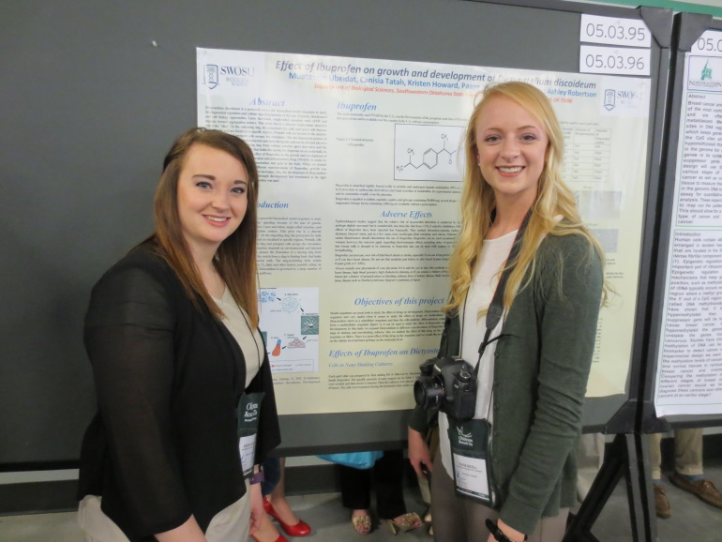
Students Kristen Howard and Paage Nicoll

Evaluating the Mechanism of Induced Resistance by Pseudomonas putida Against pseudomonas syringae Infection
Regina McGrane, Faculty
Rukayat Idris, Student
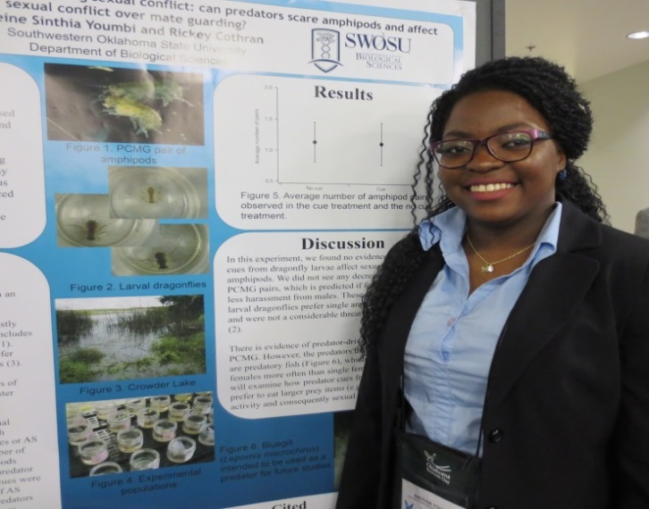
Student Sinthia Youmbi

Construction of an Efficient Expression System for Functional Analysis of the Magnetosome Protein Mad2 from Fesulfovibrio magneticus
RS-1
Denis Trubitsyn, Faculty
Rickey Cothran, Faculty
Carlene Kinder, Student
Sarah Dengler, Student
Bradly Burke, Student
Mazie Earl, Student
Emily Kessler, Student
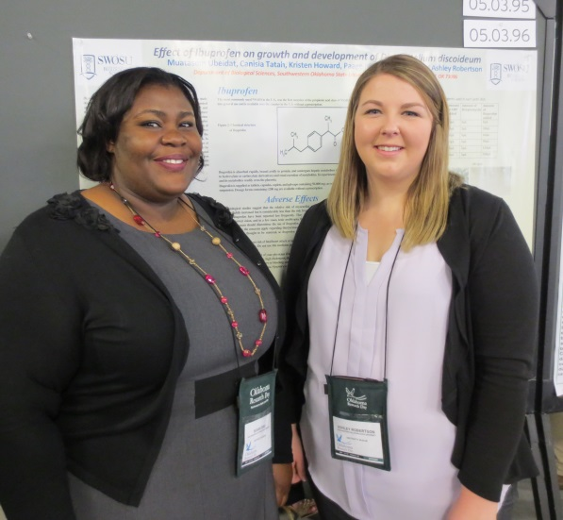
Students Susan Eno and Ashley Robertson

Cost of Courtship; Effect of Male-Male Competition on Harm Experienced by Females in Hyalella
Rickey Cothran, Faculty
Ashna Dhoonmoon, Student
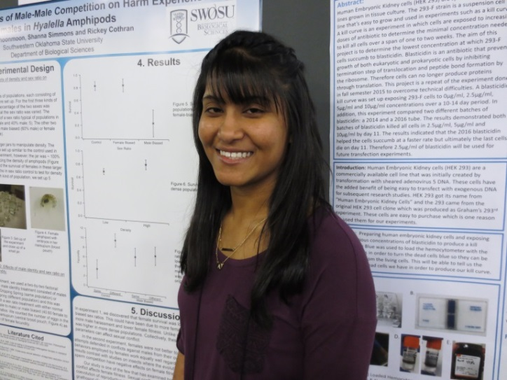
Student Ashna Dhoonmoon

Effect of Ibuprofen on Growth and Developmentof Dictyostelium discoideum
Muatasem Ubeidat, Faculty
Ashley Robertson, Student
Canisia Tatah, Student
Kristen Howard, Student
Paage Nicoll, Student
Susan Eno, Student

Chemistry
Investigating the Origin of GTP Inhibition within e. coli CTP Synthetase
Jason Johnson, Faculty
Ashley Pickens, Student
Social Sciences
The Evolution of Abortion Law Statutes in Oklahoma
Bailey DeFilippo, Student

The Great Debate: Should Guns be Allowed on College Campuses?
Dan Brown, Faculty

PTSD in Corrections: The Unspoken Reality Affecting Correctional Officers
Stacey Scheurer, Student

COLLEGE OF PROFESSIONAL AND GRADUATE STUDIES

Business & Computer Science
Increase the Accessibility of Space Based Sensor Data through the Development of Automated Sensor Fusion Tools Implemented on High Performance Computing (HPC) Assets
Prabhjyot Saluja, Student
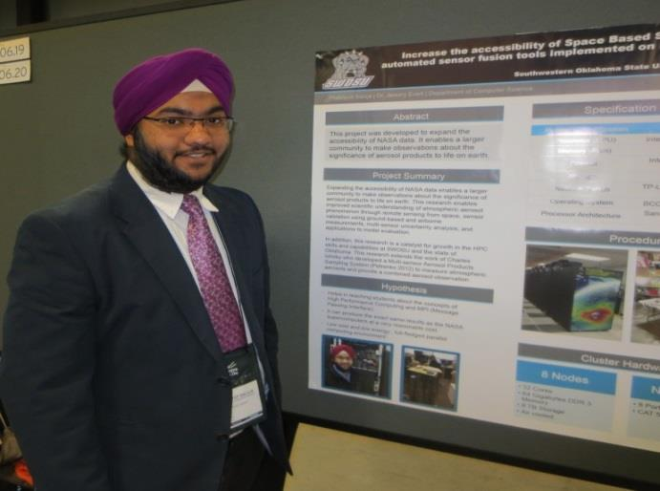
Student Prabhjyot Saluja

Expansion of Multi-Sensor Aerosol Products Sampling System (MAPSS)
Dean Phares, Student

Expanding Accessibility of NASA’s Space-Based Aerosol Sensor Data Using Oklahoma State University’s “Cowboy” Supercomputer
Amy Vantrease, Student

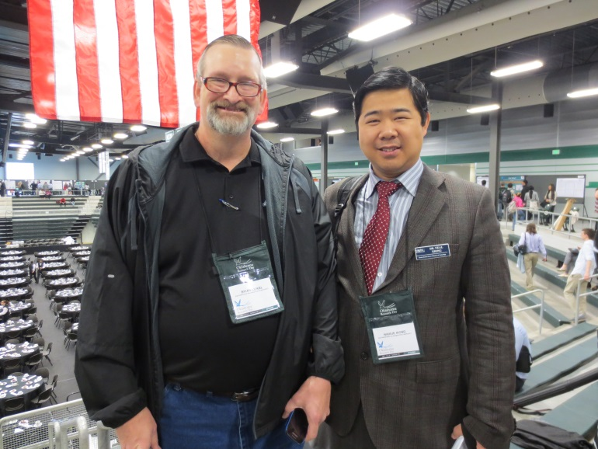
Faculty members Drs. Brian Rickel and Neal Xiong

Expanded Accessibiltiy of NASA’s Space Based Sensor Data using Low-cost Raspberry PI Clusters
Devin Smoot, Student

Expanding Accessibility of NASA’s Space-Based Aerosol Sensor Data using Texas Advanced Computing Center’s Stampede Supercomputer
Varun Reddy Nagireddy

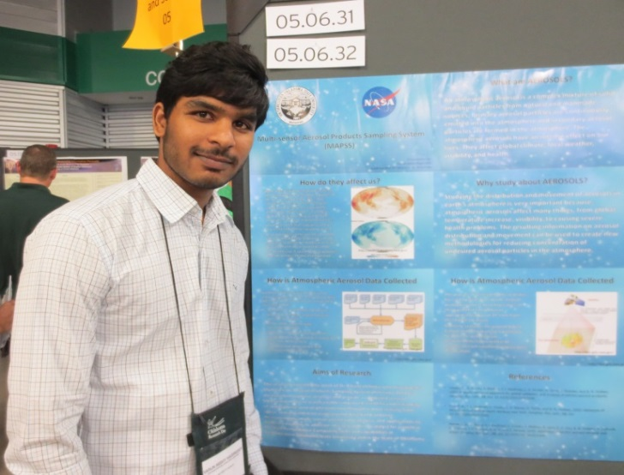
Student Varun Reddy Nagireddy

Engineering Technology
Stereo Vision and Navigation for Land Based Robotic Systems
Nick Rymer, Student
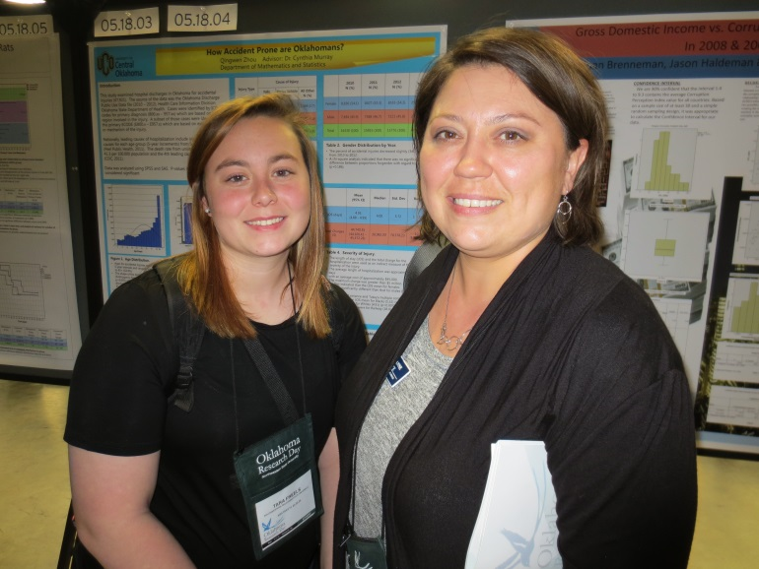
Student Tara Freels and Dr. Anne Pate

Nursing and Allied Health Sciences

Epidemiology of Testicular Cancer in Oklahoma
Anne Pate, Faculty
Dylan Biggs, Student
Ben Hill, Student
Colton Henricks, Student

Epidemiology of Colorectal Cancer in Oklahoma
Anne Pate, Faculty
Tara Freels, Student
Seth Odam, Student

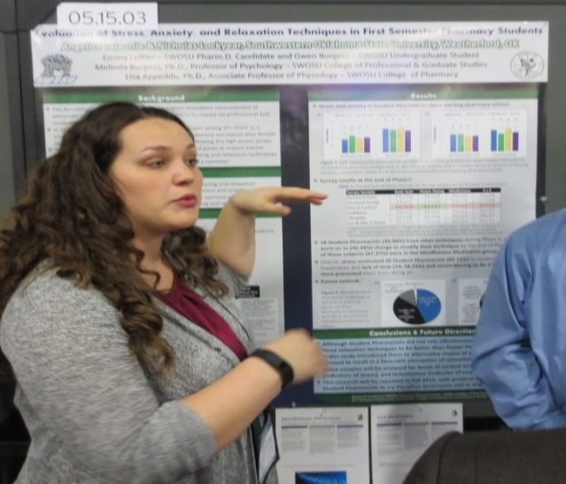
Student Angelica Lajaunie

Pharmaceutical Sciences
Evaluation of Stress, Anxiety, and Relaxation Techniques in First Semester Pharmacy Students
Lisa Appeddu, Faculty
Melinda Burgess, Faculty
Gwen Burgess, Student
Emma Leffler, Student
Nicholas Lockyear, Student
Angelica Lajaunie, Student

Evaluation of the Immediate Impact of Relaxation Techniques on Student Psychological and Physiological Health
Lisa Appeddu, Faculty
Melinda Burgess, Faculty
Gwen Burgess, Student
Emma Leffler, Student
Nicholas Lockyear, Student
Angelica Lajaunie, Student
Heather Kelley, Student
Aminatou Mouliom, Student

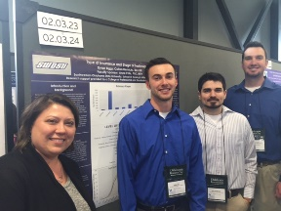
Dr. Pate with students Ben Hill, Dylan Biggs,
and Colton Henricks.

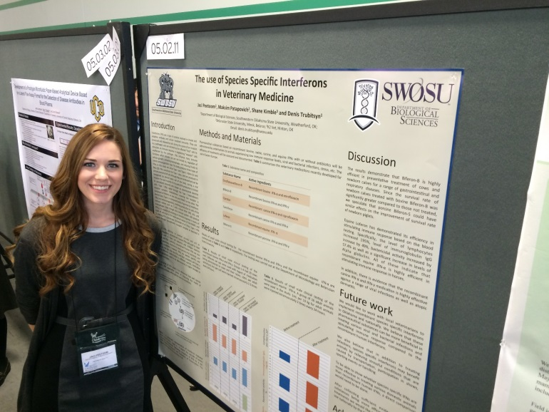
Student Jaci Peetoom
GRANTS, CONTRACTS AND PROPOSALS
AWARDS
The following grants and contracts were awarded by Southwestern Oklahoma State University faculty and staff since the last report:
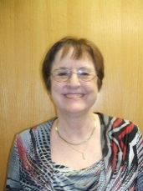
Madeline Baugher, Business and Computer Science. Oklahoma NASA Space Grant Consortium - NASA Partnership with Community Colleges. National Aeronautics and Space Administration. $2,070.
Madeline Baugher, Business and Computer Science. Oklahoma NASA Space Grant Consortium - NASA Partnership with Community Colleges. National Aeronautics and Space Administration. $4,600.
Madeline Baugher, Business and Computer Science. Oklahoma Space Grant Consortium - NASA Partnership with Community Colleges. National Aeronautics and Space Administration (NASA). $11,416.

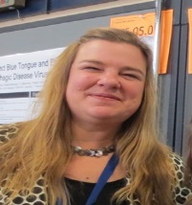
Lisa Castle, Biological Sciences. Presentation at Economic Botany/Open Science Network Meeting. National Institutes of Health. $1,324.

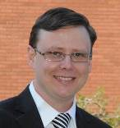
Rickey Cothran, Biological Sciences. Sexual selection in a changing world: How Human-induced environmental changes affects sexual selection and consequently the health of populations. PLE Early Career Fellowship. $5,000.

Amanda Evert, Business and Computer Science. SWOSU Single Moms’ Network. Oklahoma Women’s Foundation. $3,500.

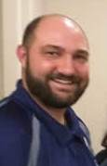
Jeremy Evert, Business and Computer Science. Undergraduate research in spaced-based climate and radiation data using high performance computing. National Aeronautics and Space Administration (NASA), $35,935.

Jeremy Evert, Business and Computer Science. Undergraduate research of high performance computing and data analytics for the study of large data sets. National Aeronautics and Space Administration (NASA). $2,817.23.

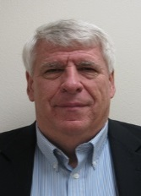
Brad Fitzgerald, Engineering Technology. First Tech Challenge (FTC) Robotics. City of Weatherford, Hotel-Motel Tax Advisory Council. $2,300.

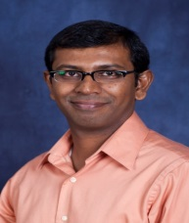
Eric Paul, Biological Sciences. Pathogenesis of Pseudomonas aeruginosa in Microgravity. National Institutes of Health. $2,000.

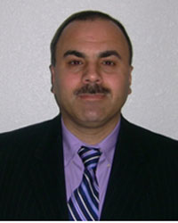
Muatasem Ubeidat, Biological Sciences. 2016 Oklahoma INBRE Carryforward Equipment Support Award. National Institutes of Health. Oklahoma IDeA Network of Biomedical Research Excellence.
$25,000.

John Woods, Mathematics. KESAM Statewide Partnerships 2016. Oklahoma State Regents for Higher Education. $133,177.50.

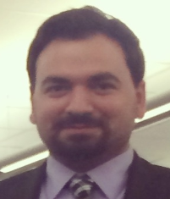
Proposals Submitted
Madeline Baugher, Business and Computer Science. Space Grant College and Fellowship Program. National Aeronautics and Space Administration. $56,924.

Rickey Cothran, Biological Sciences. A survey for rare mayfly and caddisfly species of greatest conservation need. Oklahoma Department of Wildlife and Conservation. $72,660.

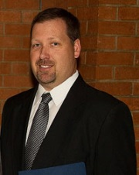
Tim Hubin, Chemistry and Physics. NSF Supplemental to OK-LSAMP for Student Research in Hull. National Science Foundation. $28,500.

Tim Hubin, Chemistry and Physics. PET Imaging and Therapy of CXCRu-Expressing Cancers. OK-INBRE. $135,000.

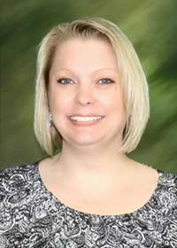
Jamie Novey, Upward Bound Program. Summer Food Services Program for Children. State Department of Education/ U.S. Department of Agriculture. $7,100.

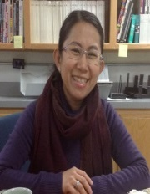
Siriporn Peters, Art, Communication, and Theatre. Cheyenne Art Workshop and Exhibition. The Oklahoma Arts Council. $2,650.

Siriporn Peters, Art, Communication, and Theatre. Ceramic Art Workshop and Exhibition. The Oklahoma Arts Council. $3,330.

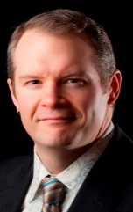
Richard Tirk, Music. The 47th Annual SWOSU Jazz Festival. The Oklahoma Art Council. $6,080.
Denis Trubitsyn, Biological Sciences. Bioinformatics and quantitative real-time PCR analysis of magnetosome formation genes. National Institutes of Health. $14,561.80.

GRANTS, CONTRACTS AND PROPOSALS
Faculty interested in pursuing grant opportunities can contact the Office of Sponsored Programs about conducting a fund opportunity search. The process can be started by completing the Research/Scholarly Activity Interest Profile at the Office of Sponsored Programs web site at
www.swosu.edu/administration/osp/osp_interest_survey.aspx

FUNDING OPPORTUNITIES

Deadline Date: January 7, 2019
Funding Agency: National Institutes of Health
Program Title: Ruth L. Kirschstein National
Research Service Award (NRSA) Institutional
Research Training Grant (Parent T32)
Web site: http://grants.nih.gov/grants/guide/pa-files/PA-16-152.html
Synopsis: The National Institutes of Health (NIH) will award Ruth L. Kirschstein National Research Service Award (NRSA) Institutional Research Training Grants (T32) to eligible, domestic institutions to enhance pre-doctoral and postdoctoral research training, including short-term research training, and help ensure that a diverse and highly trained workforce is available to meet the needs of the Nations biomedical, behavioral, and clinical research agenda. Research training programs will incorporate didactic, research, and career development elements to prepare individuals for careers that will have a significant impact on the health-related research needs of the Nation.
Funding Range: up to $500,000

FUNDING OPPORTUNITIES

Deadline Date: June 1, 2016
Funding Agency: United States Department of Agriculture
Program Title: Rural Health and Safety Education Competitive Grants Program
Web site: https://nifa.usda.gov/funding-opportunity/rural-health-and -safety-education-competitive-grants-program-rhse
Synopsis: The RHSE program proposals are expected to be community-based, outreach education programs, such as those conducted through Human Science extension outreach, that provides individuals and families with: Information as to the value of good health at any age; Information to increase individual or family’s motivation to take more responsibility for their own health; Information regarding rural environmental health issues that directly impact on human health; Information about and access to health promotion and educational activities; and Training for volunteers and health services providers concerning health promotion and health care services for individuals and families in cooperation with state, local and community partners.
Funding Range: $250,000-$350,000
******************************************

Deadline Date: May 07, 2019
Funding Agency: Department of Health and Human Services/National Institutes of Health
Program Title: NIH Small Research Grant Program (Parent R03)
Web site: http://grants.nih.gov/grants/guide/pa-files/PA-16-162.html
Synopsis: The NIH Small Research Grant Program supports small research projects that can be carried out in a short period of time with limited resources. This program supports different types of projects including pilot and feasibility studies; secondary analysis of existing data; small, self-contained research projects; development of research methodology; and development of new research technology.
Funding Range: $50,000

Deadline Date(s): July 14, 2016
Funding Agency: National Endowment for the Arts
Program Title: Art Works
Web site: https://www.arts.gov/grants organizations/art-works/award-information
Synopsis: The guiding principle of "Art Works" is at the center of everything we do at the NEA. "Art Works" refers to three things: the works of art themselves, the ways art works on audiences, and the fact that art is work for the artists and arts professionals who make up the field. Art works by enhancing the value of individuals and communities, by connecting us to each other and to something greater than ourselves, and by empowering creativity and innovation in our society and economy. To deepen and extend the arts' value, including their ability to foster new connections and to exemplify creativity and innovation, we welcome projects that: Are likely to prove transformative with the potential for meaningful change, whether in the development or enhancement of new or existing art forms, new approaches to the creation or presentation of art, or new ways of engaging the public with art; Are distinctive, offering fresh insights and new value for their fields and/or the public through unconventional solutions; and; Have the potential to be shared and/or emulated, or are likely to lead to other advances in the field.
Funding Range: $10,000 - $100,000
********************************************** Deadline Date(s): December 7, 2016
Funding Agency: National Endowment for the Humanities
Program Title: Collaborative Research Grants
Web site: http://www.neh.gov/grants/research/collaborative-research-grants
Synopsis: Collaborative Research Grants support interpretive humanities research undertaken by two or more collaborating scholars, for full-time or part- time activities for periods of one to three years. Support is available for various combinations of scholars, consultants, and research assistants; project-related travel; field work; applications of information technology; and technical support and services. All grantees are expected to disseminate the results of their work to the appropriate scholarly and public audiences. Eligible projects include research that significantly adds to knowledge and understanding of the humanities; conferences on topics of major importance in the humanities that will benefit scholarly research; and archaeological projects that include the interpretation and dissemination of results.
Funding Range: $40,000

UPCOMING EVENTS

PROPOSAL WRITING INSTITUTE
August 4-8, 2016 – Kellogg West Conference Center & Hotel, Pomona CA
Application Deadline: Friday, June 17, 2016
This Institute will bring together faculty and administrators interested in preparing proposals for submission to external funding agencies. The four-day institute will consist of one-on-one work with a mentor, writing, small group discussions, and critiquing of proposals. The institute has been developed to assist novice to experienced proposal writers in drafting complete proposals for submission. Prior to the institute participants will be able to access information that will help them begin to draft their proposal. Applicants must submit a one to two paragraph outline of their proposal and the name of the intended funding agency and program in the on-line application. Time at the Institute will consist of periods of proposal preparation interspersed with one-on-one mentoring by experienced and successful proposal writers, members of grants review panels, former program officers, and Directors of Sponsored Programs Offices. Also, small group discussions and group critiquing sessions will be held. Participants who come well prepared and who work hard should be able to leave the Institute with a completed (or nearly completed) proposal to the granting agency of their choice. A $50.00 application fee is due at the time of application.
Application Deadline: June 17, 2016.
For more information, please contact:
Tavia Cummings, CMP
Manager for Institutes and Meeting Services
Council on Undergraduate Research
734 15th St. NW, Ste. 550
Washington, DC 20005
tcummings@cur.org

CUR BIENNIAL CONFERENCE 2016
CUR is hosting its 17th National Conference, “Advancing Undergraduate Research: Collaboration and Innovation in a Global Society”, at the University of South Florida, Tampa, one of only four Florida public universities classified by the Carnegie Foundation for the Advancement of Teaching in the top tier of research universities. The conference date is June 26-28, 2016. The 2016 CUR National Conference provides an opportunity for faculty, administrators, staff, academic and community partners, and policymakers to share individual and collaborative investigations, either interdisciplinary or cross-disciplinary, in local, national and international contexts, and to showcase models of undergraduate research activities at all types of higher education institutions. In addition, the conference features nationally-recognized keynote speakers who provide insight into current national/global trends and related fields of interest.
The last day to register at the early-bird rate is April 25, 2016. Registration closes on May 25, 2016. For more information, please visit the website at
http://www.cur.org/conferences_and_events/biennial2016/

2016 OSRHE Summer Grant Writing Training and Assistance

Searching for Grant Resources
1:00 p.m. to 3:00 p.m.
Thursday, May 19th, 2016
655 Research Parkway
3 South Conference Room
Limit 15 participants
No charge
Please bring a computer for searching.
Register by emailing Lmason@osrhe.edu by May 17.

Beginning Grantwriting
9:00 a.m. to 4:00 p.m.
Friday, May 20th, 2016
840 Research Parkway
450 Conference Room
Limit 24 participants
No charge
Please bring a computer for writing exercises. Register by emailing Lmason@osrhe.edu by May 17.
Advanced Grant Proposal Formation
9:00 a.m. to 4:00 p.m.
Tuesday and Wednesday, June 7 and 8
840 Research Parkway
450 Conference Room
Limit 12 participants
No charge
Please bring a computer and a current proposal draft for editing work.
Register by emailing Lmason@osrhe.edu by June 3.

OFFICE OF SPONSORED PROGRAMS STAFF
Dr. Yolanda Carr, Director
yolanda.carr@swosu.edu
***
Ms. Kem Mendizabal, Grants Specialist
kem.mendizabal@swosu.edu
***
ADM 201
(580) 774-7012
osp@swosu.edu

osp@swosu.edu

