Newsletter

THE SOURCE
OFFICE OF SPONSORED PROGRAMS
Volume 4, Issue 1
September 10, 2016

SWOSU Student Awarded Summer Internship
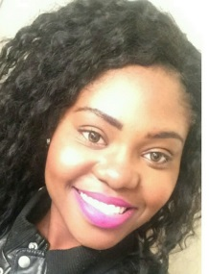
Mouliom Aminatou, a junior Pre-Pharmacy major and Chemistry minor, was awarded a summer internship at Novartis Institutes for Biomedical Research in Cambridge, Massachusetts. Mouliom enrolled as a SWOSU student in 2014, and one of her goals was to eventually work in the pharmaceutical industry. However, she did not know how she would get an opportunity to work in the industry before becoming a pharmacist. Mouliom visited SWOSU’s library to ask Frederic Murray, Instructional Services Librarian, for assistance in locating internships. Mr. Murray printed a list of pharmaceutical companies and their descriptions from the database for Mouliom to review. The research of the companies led her to apply at Novartis. The internship was for 10 weeks and included a grade point average and academic major requirement and, as an international student who grew up in Cameroon, South Africa, Mouliom was able to apply.
The internship paid for her travel to Massachusetts and housing accommodations. She completed the required application and asked members of the SWOSU faculty to write letters of recommendation. Dr. Hardeep Saluja prepared Mouliom for the telephone interview by taking her through mock interviews. When Mouliom received notification that she was selected for the internship, she was very excited.
At Novartis, Mouliom was assigned to work with the Manager of Animal Welfare Compliance and her team. This department was responsible for overseeing animal use and care in research and ensuring that scientists using animals in their
research was in compliance with the rules and regulations. “The skills and knowledge I gained will take me a long way. Also, I got to listen to professors from Harvard, and interacted with scientists from different departments,” Mouliom stated. Mouliom also had an opportunity to tour Boston and see all the amazing views.
“I wish to congratulate ‘Aminatou’ for successfully obtaining and completing her internship at Novartis Institutes for Biomedical Research in Cambridge. She gained invaluable experience working at NIBR. She got an opportunity to meet, work and network with some of the top scientists and academicians around the world. She is a very hard working, dedicated and an intelligent student. I wish her good luck with her future endeavors,” stated Dr. Saluja. Mouliom realized that there were many opportunities available for students to pursue that they do not know about. “I think it is very important for undergraduate students to participate in internships to broaden their knowledge and open doors for future opportunities.”
“Mouliom is one of the many SWOSU students who received summer internships this year. We are proud that she was able to have this experience. Students who participate in research and internships often view the remainder of their education in a different light because of the confidence, knowledge, and skills which they gain,” said Dr. James South, Provost and Vice President for Academic Affairs at SWOSU.
Inside This Issue
Page 1 Student Awarded Summer Internship
Page 2-3 Principal Investigators Reception
Page 3-5 Scholarly and Academic Activity
Page 5-6 Grants, Contracts, and Proposals
Page 7 Funding Opportunities
Page 8 Upcoming Events

Principal Investigator Recognition Reception Held
The Principal Investigator Recognition Reception was held on Tuesday, August 23rd 2016, at 6:00 p.m.
More than 40 faculty and staff were honored for their work in obtaining external funding to support research and other scholarly activities at SWOSU. Recognition gifts were presented to the honorees by President Randy Beutler, Provost James South, and Yolanda Carr, Director of Sponsored Programs.
The honorees were Ms. Cindi Albrightson, Engineering Technology; Dr. Lisa Appeddu, Pharmaceutical Sciences; Dr. Randy Barnett, Psychology; Ms. Madeline Baugher, Business and Computer Science; Ms. Terry Billey, Sayre Campus; Dr. Guy Biyogmam, Mathematics; Dr. Ruth Boyd, Vice President of Student Affairs; Mr. Brad Bryant, Engineering Technology; Dr. Brian Campbell, Chemistry and Physics; Dr. Lisa Castle, Biological Sciences; Dr. Rickey Cothran, Biological Sciences; Dr. Jorie Edwards, Psychology; Dr. Trevor Ellis, Chemistry and Physics; Dr. David Esjornson, Chemistry and Physics; Dr. Amanda Evert, Business and Computer Science; Dr. Jeremy Evert, Business and Computer Science; Mr. Brad Fitzgerald, Engineering Technology; Ms. Marci Grant, Center for Excellence in Teaching and Learning; Dr. Lori Gwyn, Chemistry and Physics; Dr. Aimee Henderson, College of Pharmacy; Dr. Jon Henrikson, Chemistry and Physics; Dr. Andrea Holgado, Biological Sciences; Dr. Christopher Horton, Biological Sciences; Dr. Tim Hubin, Chemistry and Physics; Dr. E.K. Jeong, Art, Communications and Theatre; Dr. Sophia Lee, Music; Dr. Doug Linder, Chemistry and Physics; Ms. Brenda Lumpkin, College of Professional and Graduate Studies; Ms. Sherron Manning, Sayre Campus; Dr. Shelley Martinson, Music; Dr. Regina McGrane, Biological Sciences; Mr. Doug Misak, Business Enterprise Center; Dr. Tami Moser, College of Pharmacy; Ms. Jamie Novey, Upward Bound; Dr. Eric Paul, Biological Sciences; Dr. Siriporn Peters, Art, Communication and Theatre; Dr. Les Ramos, Pharmaceutical Sciences; Dr. Richard Tirk, Music; Dr. Denis Trubitsyn, Biological Sciences; Dr. Muatasem Ubeidat, Biological Sciences; Dr. Monica Varner, Associate Provost; Dr. Nancy Williams, Pharmacy Practice; Dr. John Woods, Mathematics; and Ms. Kristen Woods, Psychology.

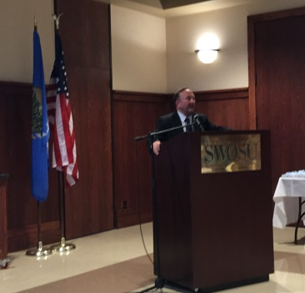
President Randy Beutler

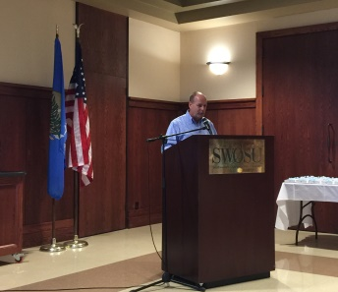
Dr. James South
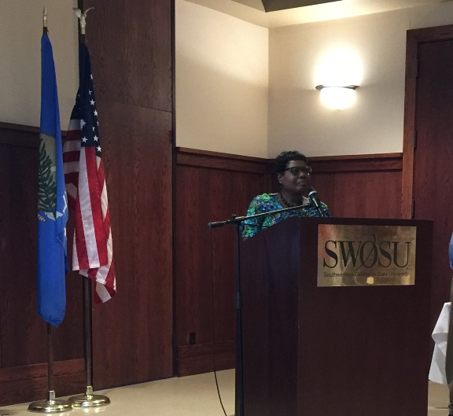
Dr. Yolanda Carr

Principal Investigators Reception (cont’d)
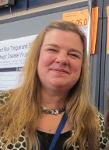
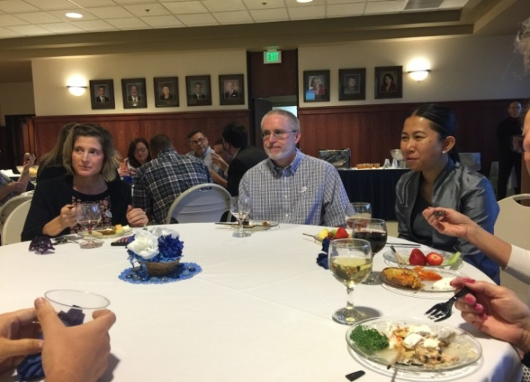Faculty Members Dr. Lisa Appeddu, Dr. Jason Johnson, and Dr. Siriporn Peters
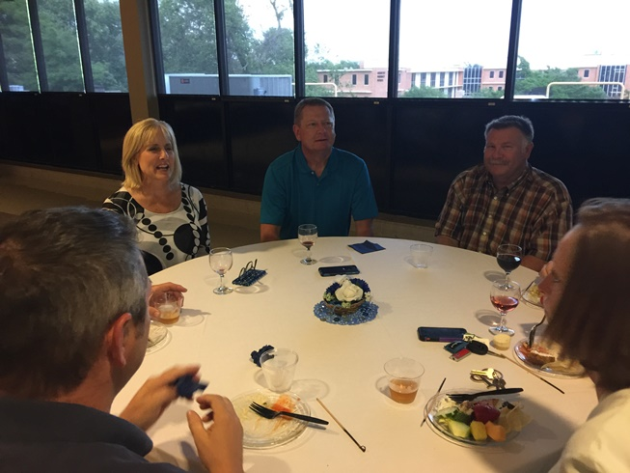
Dr. Ruth Boyd, Dr. Allen Boyd, and Doug Misak

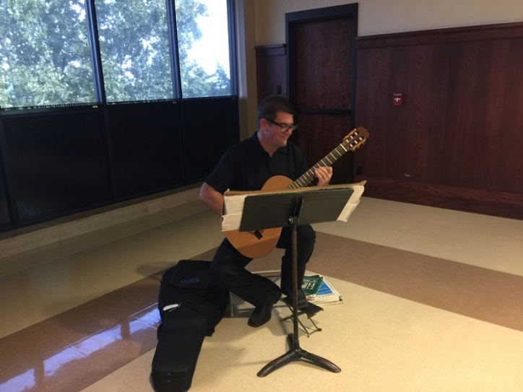
Wally Tarkington, Musician for the Reception

Scholarly and Academic Activity
The Office of Sponsored Programs has been
notified of the following Scholarly and Academic Activities since the last newsletter:
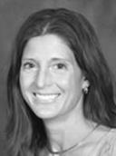
Lisa Appeddu, Pharmaceutical Sciences, presented “The Acute Impact of Relaxation Techniques on Student Psychological and Physiological Health” at the APhA National Meeting and Exposition in Baltimore, Maryland.
Lisa Castle, Biological Sciences, recently presented, “Lessons Learned from Ranking Medicinal Plants” at the Society of Economic Botany/Open Science Network in Ethnobiology meeting in Pine Mountain Settlement, Kentucky.
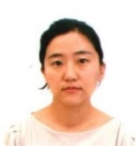
Jieun Chang, Social Sciences, recently served as chair on the Session [302] Unemployment and also presented “Broadband Technology Opportunities Program and Unemployment,” at the Western Economic Association International 91st Annual Conference in Portland, Oregon.
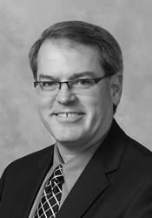
Barry Gales, Pharmacy Practice, recently reviewed the “Effect of Clinical Pharmacist Intervention on A1c Reduction in Veteran Patients with Type II Diabetes in a Rural Setting,” in the Annals of Pharmacotherapy.
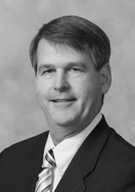
Mark Gales, Pharmacy Practice, was recently appointed to the CME Planning and Review Committee of the INTEGRIS Medical Education CME/GME in Oklahoma City, Oklahoma.
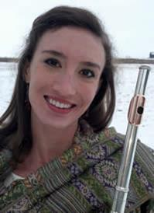
Shelley Martinson, Music, recently presented for the Career and Artistic Development Committee of the National Flute Association in Washington, D.C. where Dr. Martinson also performed a recital.

Scholarly and Academic Activity (cont’d)

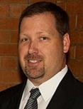
Tim Hubin, Chemistry, recently received the Oklahoma Outstanding Mentor award from the Oklahoma Foundation for Excellence. Dr. Hubin has published a number of journal articles this year:
- “Synthesis, structural studies, and oxidation catalysis of the manganese(II), iron(II), and
copper (II) complexes of a 2-pyridylmethyl pendant armed side-bridged cyclam” in Inorganic Chemistry Communications;
- “Synthesis, Structural Studies, and Oxidation Catalysis of the Late-First-Row-Transition-Metal Complexes of a 2-Pyridylmethyl Pendant-Armed Ethylene Cross-Bridged Cyclam” in Inorganic Chemistry;
- “Probing the Limits of Tetraazamacrocycle-Glyoxal Condensates as Bidentate Ligands for Cu2+” in the European Journal of Inorganic Chemistry;
- “Crystal structure of dichlorido
(4,11-dimethyl-1,4,8.11-tetraazabicyclo[6.6.2] hexadecane) iron(III) hexaflroridophosphate” in Acta Crystallographica Section E- Crystallographic Communications; and
- “Bis- and pendant armed tetraazamacrocycle transition metal complex dual CSCR4/CCR5 antagonists” and “Unsymmetric
bis-tetraazamacrocycle transition metal complexes as CXCR4 antagonists” in Abstracts of Papers of the American Chemical Society.
Dr. Hubin also presented the following papers to the Abstracts of Papers of the American Chemical Society:
- “New metals (V, Pd, Ru) and new amide pendant-arms for cross-bridged tetraazamacrocycle oxidation catalysts”;
- “Copper and nickel complexes as DNA cleavage components for use in artificial nucleases”;
- “Antifungal and anti-parasitic transition metal complexes of linked, bridged tetraazamacrocycle”; and
- “Investigation of the activity and mechanism of DNA cleavage by cobalt-cyclen and-cyclam complexes.”

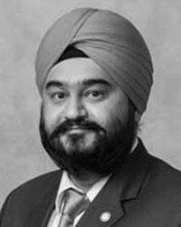
Hardeep Saluja, Pharmaceutical Sciences, recently published articles, “Evaluation of the Physicochemical Properties of a Novel Antimalarial Drug Lead, Cyclen Bisquinoline” in Modern Chemistry and Applications. Dr. Saluja also presented the article at the AACP Annual Meeting in Anaheim, California.
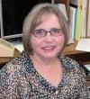
Linda Pye, Al Harris Library, was chosen to be President-Elect for the Oklahoma Library Association.

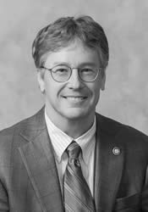
Dennis Thompson, Pharmaceutical Sciences, recently served as reviewer for a number of articles for the Abstracts of the American College of Clinical Pharmacy Annual Meeting 2017:
- “Is the Combination of Piperacillin/
Tazobactam and Vancomycin Associated with Nephrotoxicity: A Meta-analysis”;
- “Quality of the evidence on barriers to medication adherence in patients with diabetes mellitus: A systematic review of systematic reviews”;
- “Acute Kidney Injury with Concomitant Piperacillin/Tazobactam and Vancomycin: Systematic Review”;
- “Comparison of the incidence of pneumonia in patients with multi-trauma and TBI versus those without TBI”;
- “Potency evaluation of extemporaneously compounded bioidentical hormones”;
- “Comparison of Opioid-Treated Nursing Home Residents (NHR) with and without Opioid-Induced Constipation (OIC)”;
- “Development of critical thinking among health professions students: An updated systematic review and meta-analysis of longitudinal studies”;

Scholarly and Academic Activity (cont’d)
- “The Association Between Electronic Cigarette Use and Smoking Cessation in Adult Smokers Attempting to Quit: A Systematic Review”;
- “Selexipag in Pulmonary Arterial Hypertension: A Comprehensive Review”;
- “Cariprazine for the Treatment of Schizophrenia: A Systematic Review”; and
- “Burden of Invasive pneumococcal pneumonia among Indian children: A systematic review and meta-analysis of observational studies.”
Dr. Thompson also served as a reviewer of the article, “Black hairy tongue associated with lorazepam treatment of a male smoker with major depression,” in the Journal of Clinical Psychopharmacology.

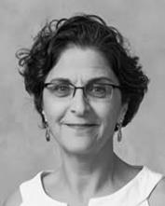
Edna Patatanian, Pharmacy Practice, was recently appointed to the Commission on Affiliate Relations in Maryland.

SCHOLARLY AND ACADEMIC ACTIVITY
Faculty are encouraged to report work, such as publications, speeches, honors, conference participation or facilitation, appointments, reviews, exhibitions, poster presentations, and other such activities.
The annual scholarly and academic activity report is distributed to university and state officials and acts as an archive of such activities at SWOSU.
The Office of Sponsored Programs also forwards submissions to the SWOSU Libraries digital repository. Information pertaining to the author’s activity will not be placed in the library’s digital repository without the consent of the author. The report form is available at
http://www.swosu.edu/administration/osp/scholarly-activity-report.aspx.

Grants, Contracts, and Proposals
AWARDS
The following grants and contracts were awarded by Southwestern Oklahoma State University faculty and staff since the last report:
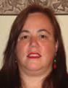
Andrea Holgado, Biological Sciences. Analysis of autophagy in neurons. National Institutes of Health.
$2,200.

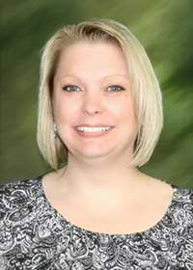
Jamie Novey, Upward Bound Program. Summer Food Services Program for Children. State Department of Education/U. S. Department of Agriculture. $7,565.29.

Jamie Novey, Upward Bound Program. SWOSU Upward Bound Program. U. S. Department of Education. $389,950.
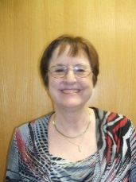
Madeline Baugher, Business and Computer Science. Space Grant Undergraduate Student Instrument Project. National Aeronautics and Space Administration. $7,939.

Madeline Baugher, Business and Computer Science. Oklahoma Space Grant Consortium - NASA Partnership with Community Colleges. National Aeronautics and Space Administration. $12,273.

Madeline Baugher, Business and Computer Science. Space Grant College & Fellowship Program - Year 2. National Aeronautics and Space Administration. $16,789.

Madeline Baugher, Business and Computer Science. Space Grant College & Fellowship Program - Year 2. National Aeronautics and Space Administration. $33,184.
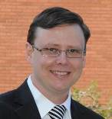
Rickey Cothran, Biological Sciences. A survey for rare mayfly and caddisfly species of greatest conservation need. Oklahoma Department of Wildlife and Conservation. $73,951.

Grants, Contracts, and Proposals (cont’d)

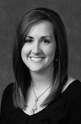
Tim Hubin, Chemistry and Physics. Inhibition of cancer metastasis with IL-24 nanotherapy and CXCR4 antagonists. National Institutes of Health. $40,766.

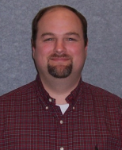
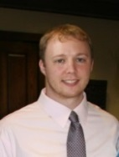
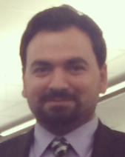
Denis Trubitsyn, Biological Sciences. Bioinformatics and quantitative real time PRC analysis of magnetosome formation genes. National Institutes of Health. $11,513.
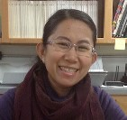
Siriporn Peters, Art, Communication and Theatre, Cheyenne Art Workshop and Exhibition.
Oklahoma Arts Council. $1,000.

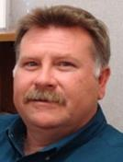
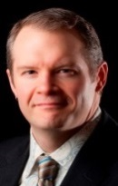
Richard Tirk, Music.
47th Annual SWOSU Jazz Festival.
Oklahoma Arts Council.
$3,000.

PROPOSALS SUBMITTED

Andrea Holgado, Biological Sciences. IOS RUI Examining Molecular Players Integrating Autophagy and Neuronal Development and Maintenance. National Science Foundation. $706,079.
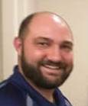
Jeremy Evert, Business and Computer Science. Multi-organization Regional One Oklahoma Friction Free Network. National Science Foundation. $61,186.
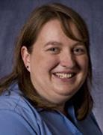
Lori Gwyn, Chemistry and Physics. Investigation of cyclen & cyclam metal ligands and oligonucleotides for the construction of Artificial Nucleases. National Institutes of Health. $264,710.

Sarah Yount, College of Pharmacy Rural Health Center. SWOSU Rural Health Center Diabetes Prevention Program. Robert Woods Johnson Foundation. $90,000.
Christopher Horton, Biological Sciences. Influence of co-receptor molecules on Th cell differentiation. OK-INBRE. $281,792.
Trevor Ellis, Chemistry and Physics. Accessing Silent Biosynthetic Pathways of Streptomyces Through Chemical Signaling. OK-INBRE. $272,062.

Doug Misak, Center for Economic and Business Development. CEBD i6 Challenge Program. U.S. Department of Commerce. $155,000.
Siriporn Peters, Art, Communication and Theatre. Collecting and Preserving Intangible Cultural Heritages. Western National Park Association. $7,500.
Siriporn Peters, Art, Communication and Theatre. Touch and See Your Park: To Support the Washita Battlefield National Historic Site, National Park Service, Cheyenne, OK. National Endowment for the Arts. $22,250.

GRANTS, CONTRACTS AND PROPOSALS
Faculty interested in pursuing grant opportunities can contact the Office of Sponsored Programs about conducting a fund opportunity search. The process can be started by completing the Research/Scholarly Activity Interest Profile at the Office of Sponsored Programs web site at
www.swosu.edu/administration/osp/osp_interest_survey.aspx

Funding Opportunities

Deadline Date(s): November 14, 2016
Funding Agency: National Institutes of Health
Program Title: NIH Big Data to Knowledge (BD2K) Enhancing Diversity in Biomedical Data Science
Web site: http://grants.nih.gov/grants/guide/rfa-files/RFA-MD-16-002.html
Synopsis: The over-arching goal of this NIH program is to support educational activities that enhance the diversity of the biomedical, behavioral, and clinical research workforce. To accomplish the stated over-arching goal, this FOA will support creative educational activities with a primary focus on research experiences and curriculum or methods development.
Funding Range: $300,000
******************************************
Deadline Date(s): May 07, 2018
Funding Agency: National Institutes of Health
Program Title: NIDDK Research Education Program Grants for Summer Research Experiences (R25)
Web site: https://www.arts.gov/grants-organizations/challenge-america/grant-program-description
Synopsis: The NIH Research Education Program supports research education activities in the mission areas of the NIH. The over-arching goal of this program is to support educational activities that complement and /or enhance the training of a workforce to meet the nations biomedical, behavioral and clinical research needs. To accomplish the stated over-arching goal, this FOA will support creative educational activities that propose summer research experiences in the research areas relevant to the NIDDK.
Funding Range: $100,000 award ceiling
******************************************
Deadline Date(s): December 06, 2016
Funding Agency: National Endowment for the Arts
Program Title: NEA Literature Fellowships: Translation Projects, FY 2018
Web site: http://www.arts.gov/grants-individuals/translation-projects
Synopsis: Through fellowships to published translators, the National Endowment for the Arts supports projects for the translation of specific works of prose, poetry, or drama from other languages into
English. We encourage translations of writers and of work that are not well represented in English translation. All proposed projects must be for creative translations of literary material into English. The work to be translated should be of interest for its literary excellence and value. Priority will be given to projects that involve work that has not previously been translated into English.
Funding Range: $12,500 - $25,000
******************************************
Deadline Date(s): October 11, 2016
Funding Agency: National Endowment for the Arts
Program Title: NEA Research: Art Works Application, FY 2017
Web site: http://www.arts.gov/grants-organizations/research-art-works
Synopsis: The National Endowment for the Arts’ Office of Research & Analysis makes awards to support research that investigates the value and/or impact of the arts, either as individual components of the U.S. arts ecology or as they interact with each other and/or with other domains of American life. In past years, the Research: Art Works category has invited researchers to propose studies that examine topics related to any area(s) on the How Art Works system map (see Grant Program Description). These projects have used quantitative, qualitative, or mixed-methods approaches, and have relied on primary and/or secondary data for analysis.
Funding Range: $10,000 - $100,000
******************************************
Deadline(s): April 01, 2017
Funding Agency: American Psychological Foundation
Program Title: Visionary Grant
Web site: http://www.apa.org/apf/funding/visionary.aspx
Synopsis: The APF Visionary Grants seek to seed innovation through supporting research, education and intervention projects and programs that use psychology to solve social problems in the following priority areas: 1) Understanding and fostering the connection between behavior and physical health to ensure well-being. 2) Reducing stigma and prejudice to promote unity and harmony. 3) Understanding and preventing violence to create a safer, more humane world. 4) Supporting programs that address the long-term psychological needs of individuals and communities in the aftermath of disaster.
Funding Range: One year grants up to $20,000

UPCOMING EVENTS

Research Day at the Capitol 2017
The Oklahoma State Regents for Higher Education (OSRHE), the Oklahoma Experimental Program to Stimulate Competitive Research (EPSCoR), and the National Science Foundation, is sponsoring the 22nd Annual Research Day at the Capitol on March 27-28, 2017.
Oklahoma colleges and universities are invited to nominate one outstanding research project conducted by an undergraduate student enrolled at their institution. Nomination packages are now being accepted online at http://www.okepscor.org/2017-rearch-day-capitol-official-nomination-form. However, please send all SWOSU nomination applications to the Office of Sponsored Programs.
The submission deadline to submit to the Regents is Tuesday, November 1, 2016.
As part of Research Day at the Capitol, students will participate in a poster competition, which will be held at the Waterford Hotel in Oklahoma City on the evening of Monday, March 27, 2017. On Tuesday, March 28, 2017, student will showcase their research projects during prescheduled visits with legislators at the State Capitol.

7th ANNUAL PROMOTING UNDERGRADUATE RESEARCH CONFERENCE
Date: Friday, September 30, 2016
Location: PHF Conference Center, OKC
Registration Fee: $50 faculty, $75 administrators
The registration deadline is September 23, 2016.
Attendees are responsible for payment of the registration fee even if they do not attend the event, unless they cancel their registration, in writing, prior to September 27, 2016. Contact Dr. Linda Mason at 405-225-9486, if you have any questions or need additional assistance.

2016 Oklahoma Women in Higher Education Conference
Date: Friday, November 18, 2016
Location: University of Central Oklahoma, Edmond
This year the conference theme is “Thriving Difficult Times.” For any questions, contact OKWHE Board members at http://www.okwhe.org/about_us.php.

Undergraduate Research and Transferable Skills Workshop
Date: Friday, October 7, 2016
Location: University of Central Oklahoma, Edmond
Oxford University Press and Dr. Julio Rivera hope you will join with them to share and discuss this important topic. Please note that space is limited and attendance should be confirmed at RSVP to Fran Ammar no later than September 23, 2016.

OFFICE OF SPONSORED PROGRAMS STAFF
Dr. Yolanda Carr, Director
yolanda.carr@swosu.edu
***
Ms. Kem Mendizabal, Grants Specialist
kem.mendizabal@swosu.edu
***
ADM 201
(580) 774-7012

