Dear student,
Elsevier HESI Testing and your school have partnered to bring you the best, most reliable testing products available.
The link below will take you directly to the page where you will make the payment by credit card. If you are having any difficulty with the link, just follow the steps below and use the payment ID 18773 on the last page.
Click on the link below and then create your Evolve account.
https://hesistudentaccess.elsevier.com/payments.html?PaymentID=18773
Payment Instructions:
- Create an Evolve Account and log in
- Register for HESI
- Go to Payments
- How To Create an Evolve Account
Under the box that says HESI Secured Exams, click on the link Register for Results and Remediation
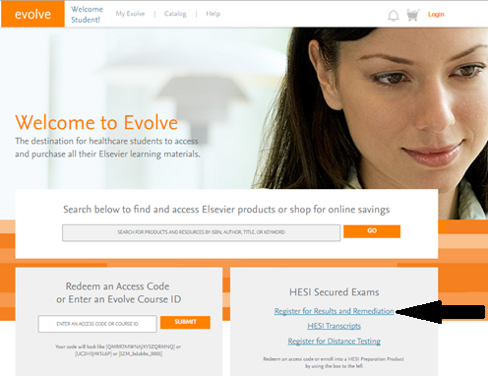

Click on the organge “register” button
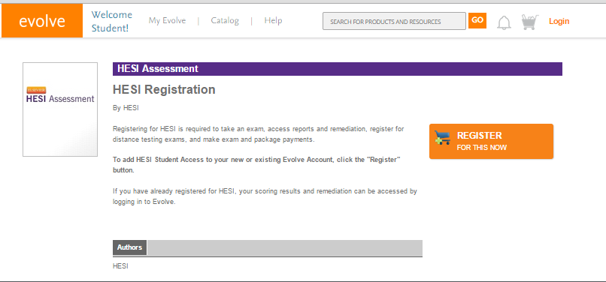
Now click on the organge “redeem checkout” button
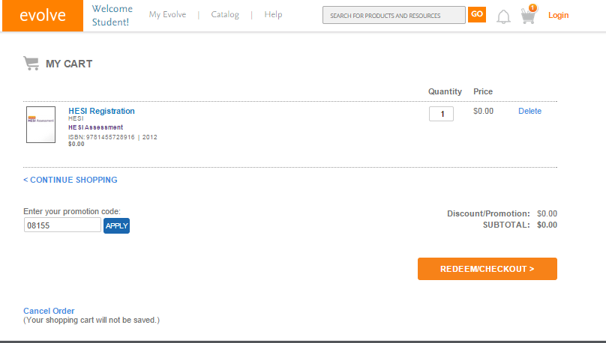

Fill in your information and click “continue”
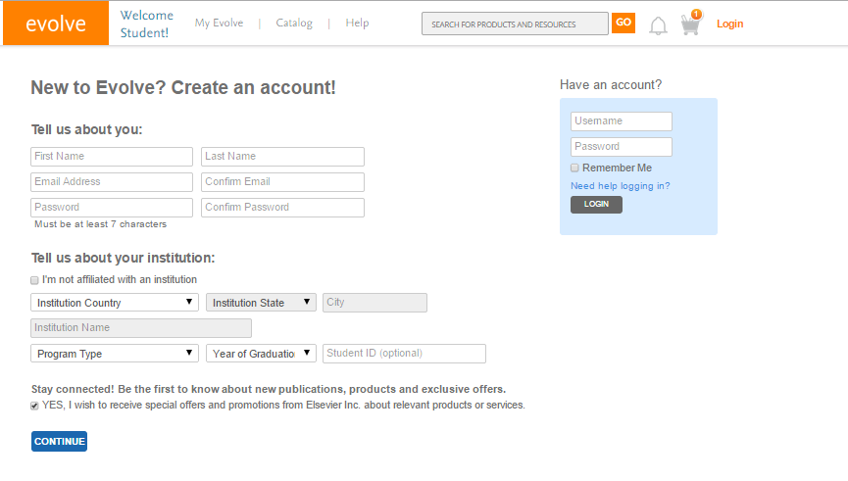
Accept the agreement by clicking on the box and then submit
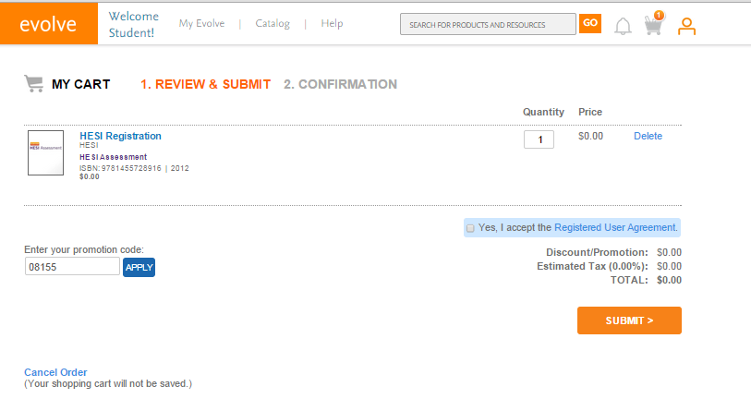

Click on the My Evolve link in the green box to go to your HESI Student Access
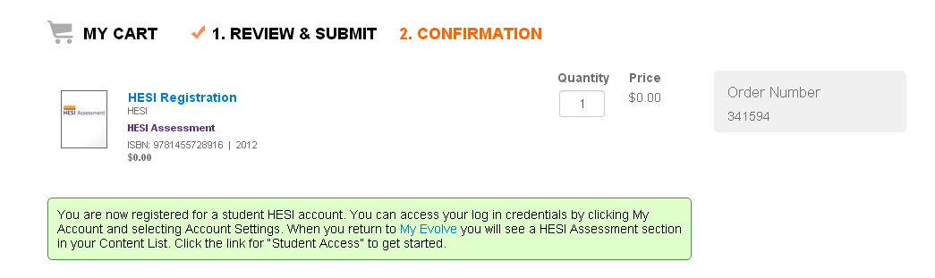
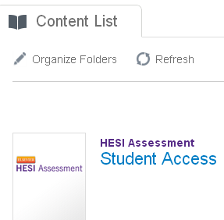

3) Now you are ready to place the order. Fill out the information on the Payment form below and click “proceed to checkout.” The payment due date is not important.
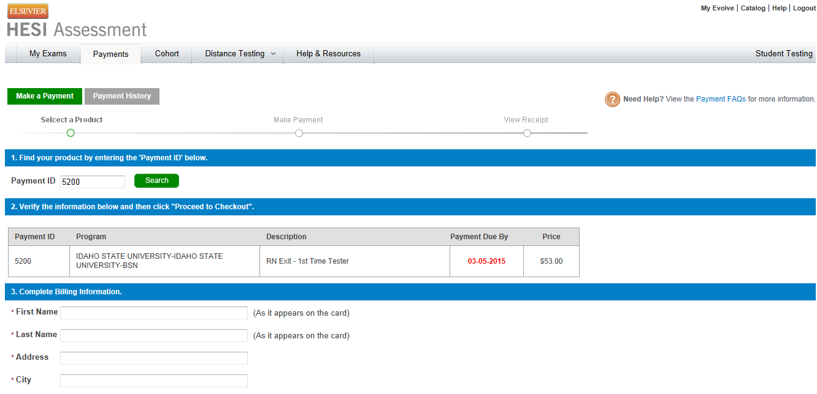
Fill out the credit card info on the screen below and you will receive a confirmation order receipt.
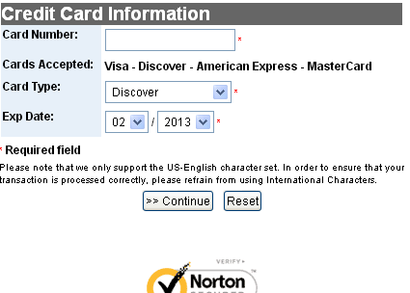
If you have any difficulty contact SUPPORT at 800 950-2728. If you still have questions, contact Liz Platz at 360 241-6822 (cell) or email l.platz@elsevier.com

